

**Hands-On Lab**

## z/OSMF Sysplex Management

## Abstract:

IBM z/OS Management Facility (z/OSMF) provides a web-based graphical user interface (UI) for z/OS sysplex management. In this hand-on lab, you will explore various views of sysplex resources and operations provided by z/OSMF Sysplex Management plugin.

This session will be useful to systems programmers and their managers who will be using or are considering using z/OSMF Sysplex Management plugin.

## Introduction: z/OSMF Sysplex Management

The Sysplex Management task simplifies the management of sysplex resources. It provides a number of graphic views to visualize the topology of your sysplex. You can view sysplexes as well as systems in a sysplex. You can view physical configurations, such as coupling facilities and LPARs, as well as logical resources, such as couple data sets and coupling facility structures. From the graphical view, you can drill down to see details. Sysplex Management task also supports a set of clickable actions which can modify sysplex resources such as CDS, CF structures, CF connections, etc. The latest enhancement also provides graphic interface for working with CFRM policies.

**z/OSMF Lab: Exploring Sysplex Management**

In this lab, you will learn about various views and actions of Sysplex Management by completing the following activities:

1. Log in to z/OSMF.

2. Open Sysplex Management.

3. Access Topology View of Sysplex.

4. Access Physical View of Sysplex.

5. View Properties of Couple Data Set

6. Open Coupling Facility Structures.

7. Access CF Connectivity View of Sysplex.

8. Access CF Connectivity Detail View of Sysplex.

9. Check Command log.

10. Switch Alternate to Primary.

11. Check Warning icon.

12. Check Notification.

13. List CFRM Policies

14. Work with CFRM Policy Editor

15. Work with CF Sizing

16. Export Policy

17. Import Policy

It is recommended that you perform these activities in the order listed. As you become more familiar with the desktop UI, you will become adept at accessing the particular tasks that you require.

As with the other labs in this session, the lab teams share access to the same z/OS system. Each team is given a unique z/OS user ID to use for the exercises. To avoid confusion, use only the user ID that is assigned to your team.

**Notes:**

1. The screen captures in this handout show the use of different user IDs. Your browser session will use the user ID that was assigned to your lab team.
2. Log in to z/OSMF

* Launch browser from your workstation
* Point browser to z/OSMF – enter the following url

<https://share.centers.ihost.com/zosmf>

* Login with SHARE userid/pw as provided by the lab instructor
* Each workstation has been assigned a unique z/OS user id

Note: All screen captures in the handout show the different user ID, your browser will be slightly different to reflect the User ID that you were given.

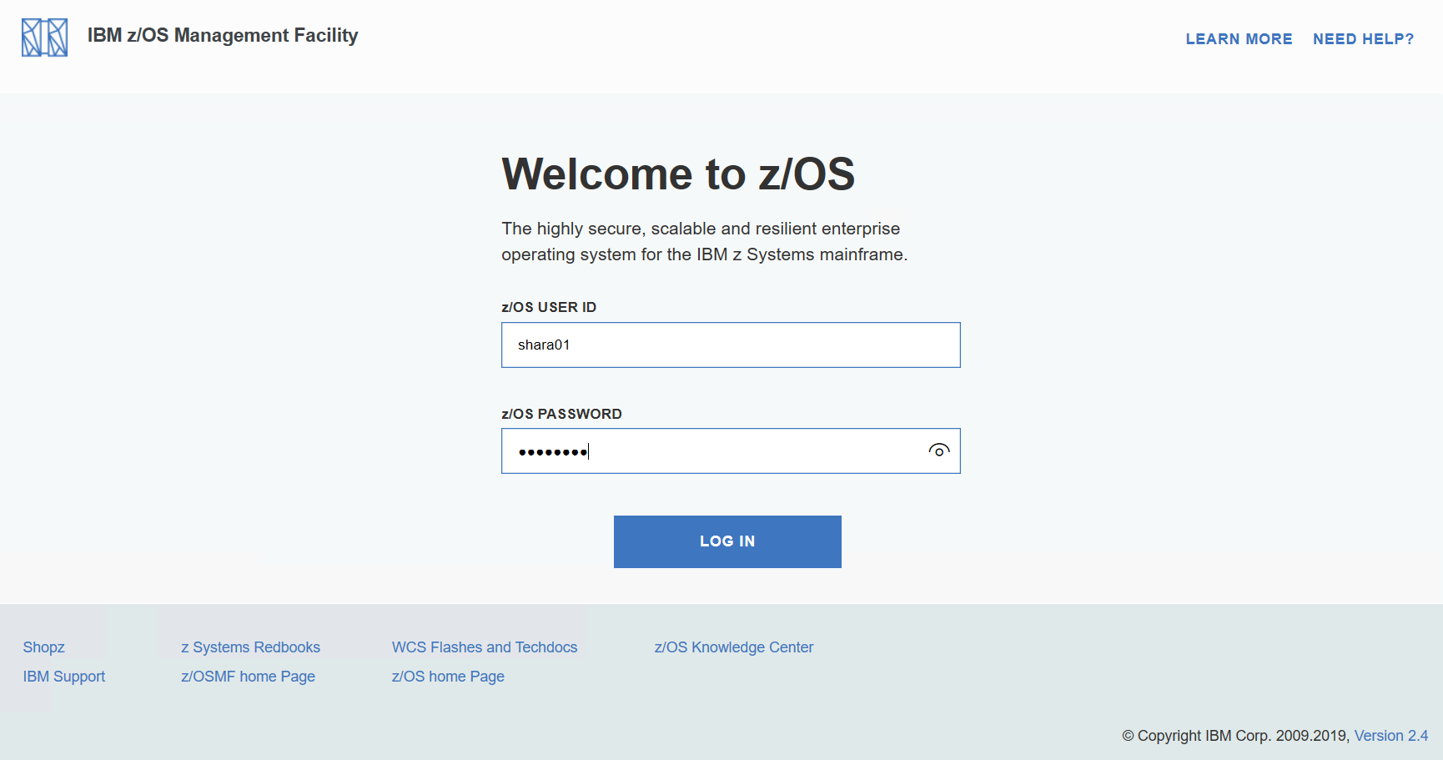

Input user ID and password that provided by the lab instructor, then you will enter the z/OSMF Desktop UI

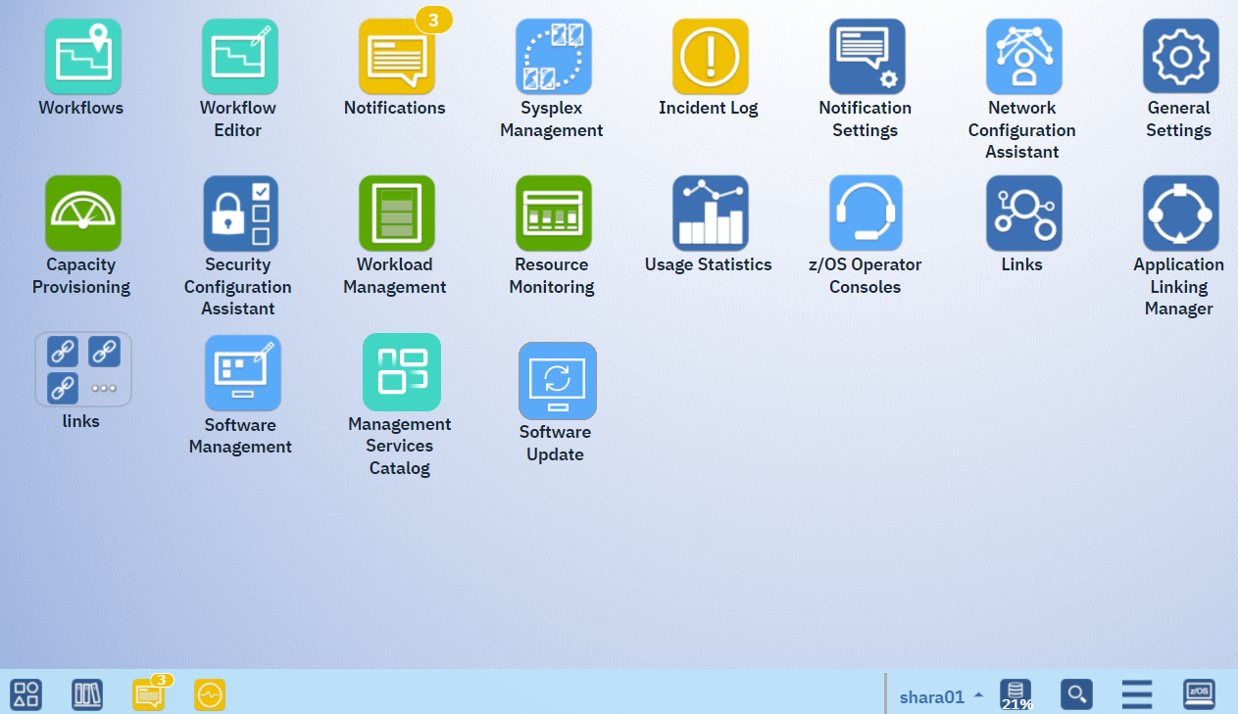

1. Open Sysplex Management

In z/OSMF Desktop interface, find the icon named **Sysplex Management**. Double click on it to open the Sysplex Management plugin. When Sysplex Management is opened, you will firstly see Topology view of Sysplex.



1. Access Topology View of Sysplex

Use the Topology View to manage your sysplex topology.

The Topology View displays the relationship between sysplexes, coupling facilities (CFs), and systems. With a proper setup in z/OSMF Systems task and typically one z/OSMF running in each sysplex, the Topology View is able to provide an enterprise view across sysplex.

The Topology View includes both a graphic view and a table view. You can drag the divider that separates the views to expand or reduce each section.

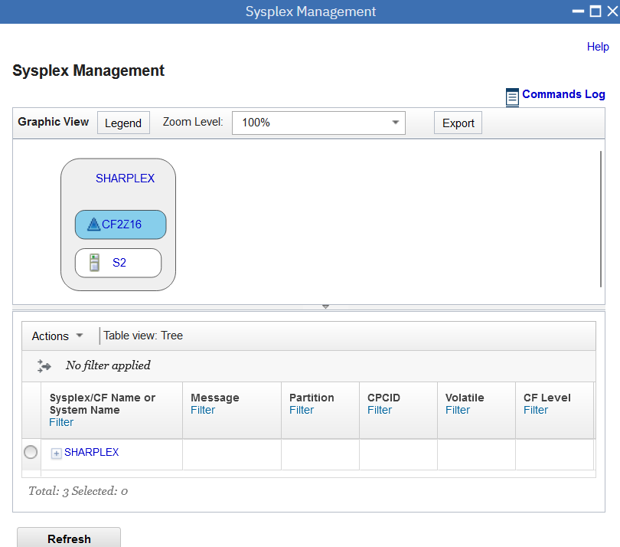

In Topology View, user can right click on sysplex name **SHARPLEX**, click **Open Physical View** to Open Physical View of Sysplex.

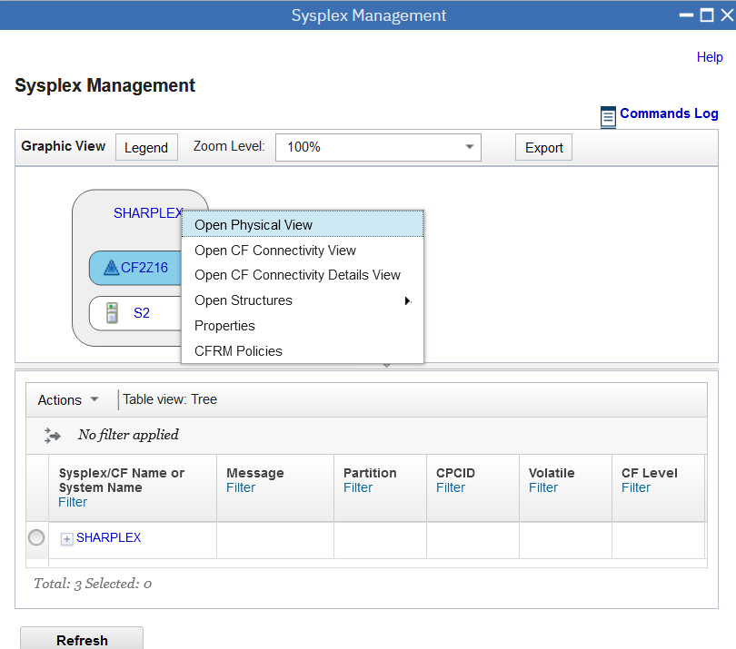

1. Access Physical View of Sysplex

Use the Physical View to manage your sysplex. The Physical View shows the major physical elements in a sysplex include Central Processor Complexes (CPCs), coupling facilities (CFs), systems, and different types of couple data sets. It includes a graphical and table view. With both the graphic and table views, you can see and manage sysplex objects, including identifying a single point of failure condition.

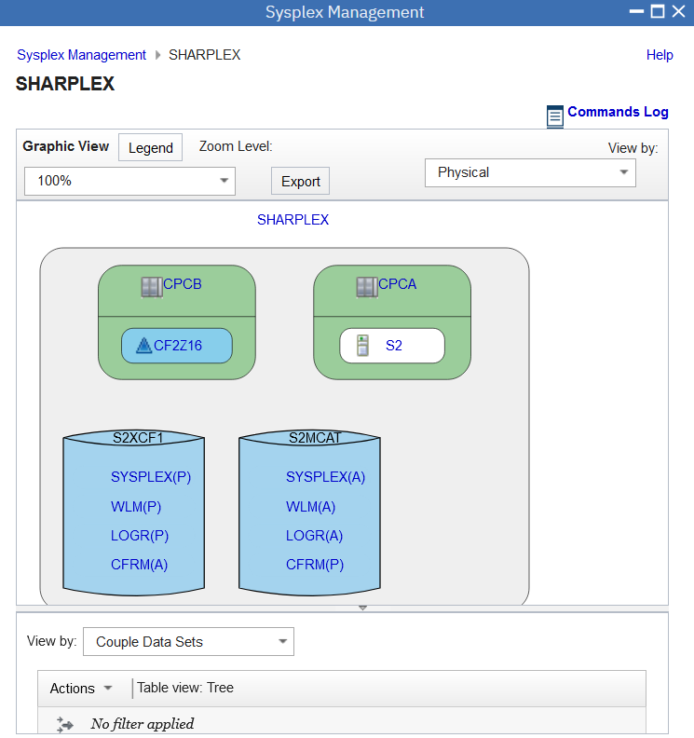

1. View Properties of Couple Data Set

The View Properties for Couple Data Set page shows the properties of a couple data set.

Move cursor to couple data set column, find **CFRM(P)** which is Primary couple data set of CFRM type, click **CFRM(P)** to open properties of CFRM.

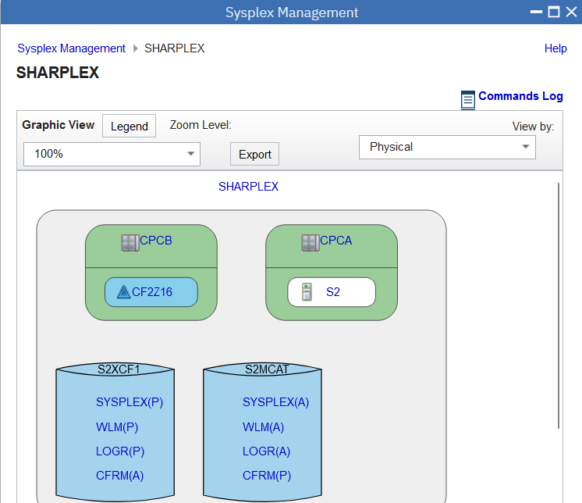

The View Properties for Couple Data Set page shows the properties of a couple data set. The page has a tab for the Primary CDS and a tab for the Alternate CDS. The title of the page indicates the type of couple data set (CFRM, ARM, LOGR, and so on).

Click **Alternate** tab to view properties of alternate couple data set.

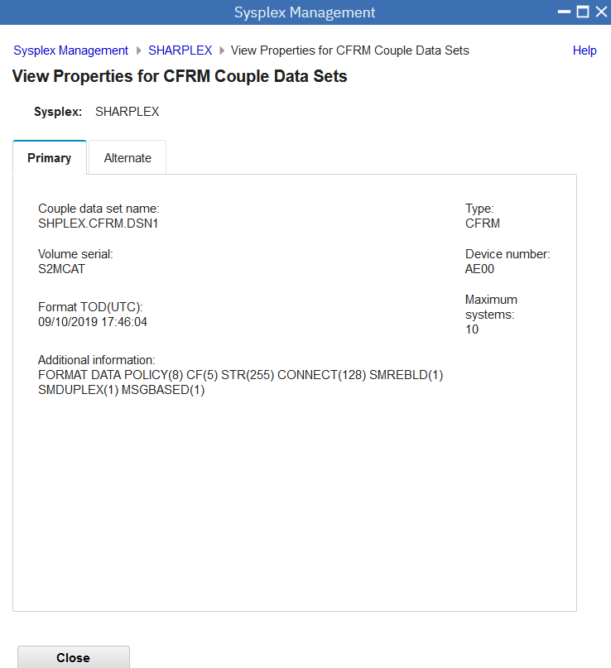

Click **Close** button to close properties page.

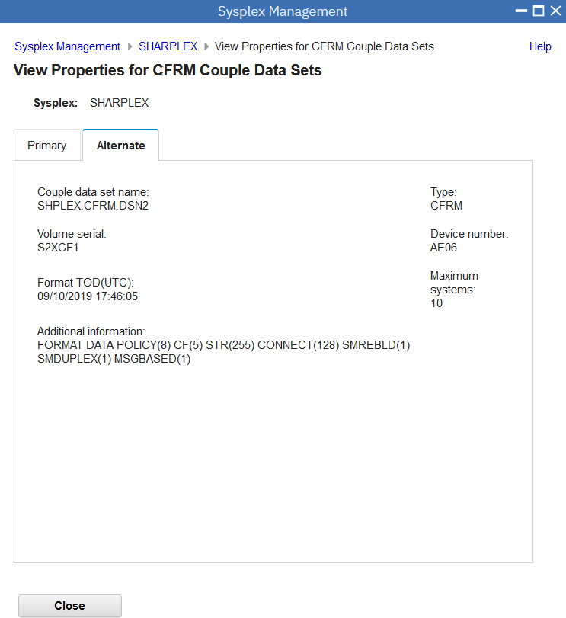

1. Open Coupling Facility Structures

From Physical View, you can view structure based on sysplex level, right click on the sysplex name **SHARPLEX**, click **Open Structures**, then click **Coupling Facility View** to open structure by Couple Facility view.

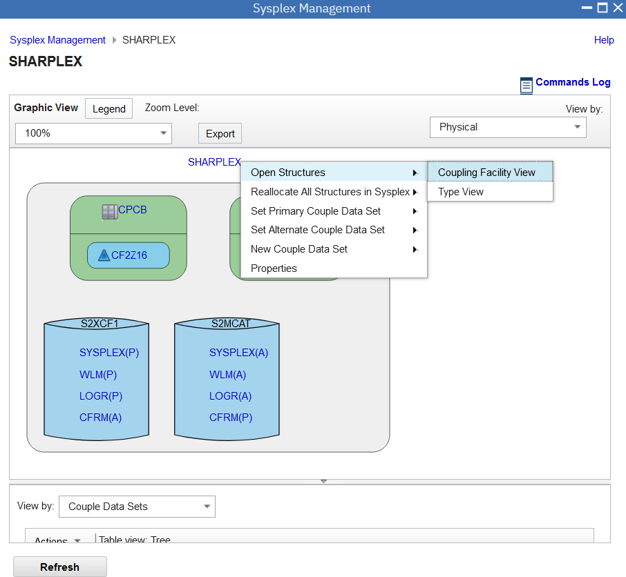

Use the Coupling Facility Structures view to see and manage your coupling facility structures by CF. It includes a graphic and a table view.

The graphic view shows:

* Coupling facilities, and objects contained by the coupling facility, representing the structures.
* Unallocated coupling facility structures, which do not have a type. They are assigned a type when they are allocated.

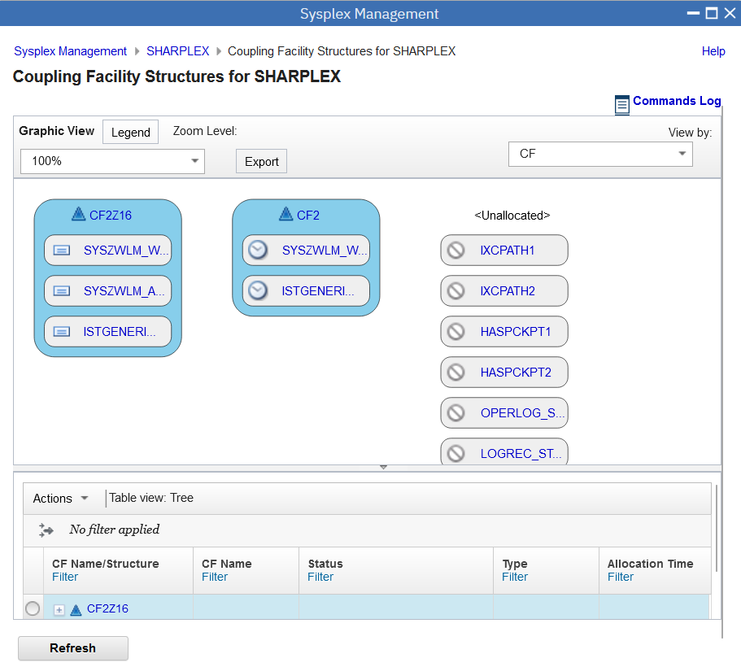

You can view coupling facility structures by type and by coupling facility. Each view includes a graphic view and a table view. Move cursor to the right top, Click **View by** arrow, select **Type** to view structure by type. 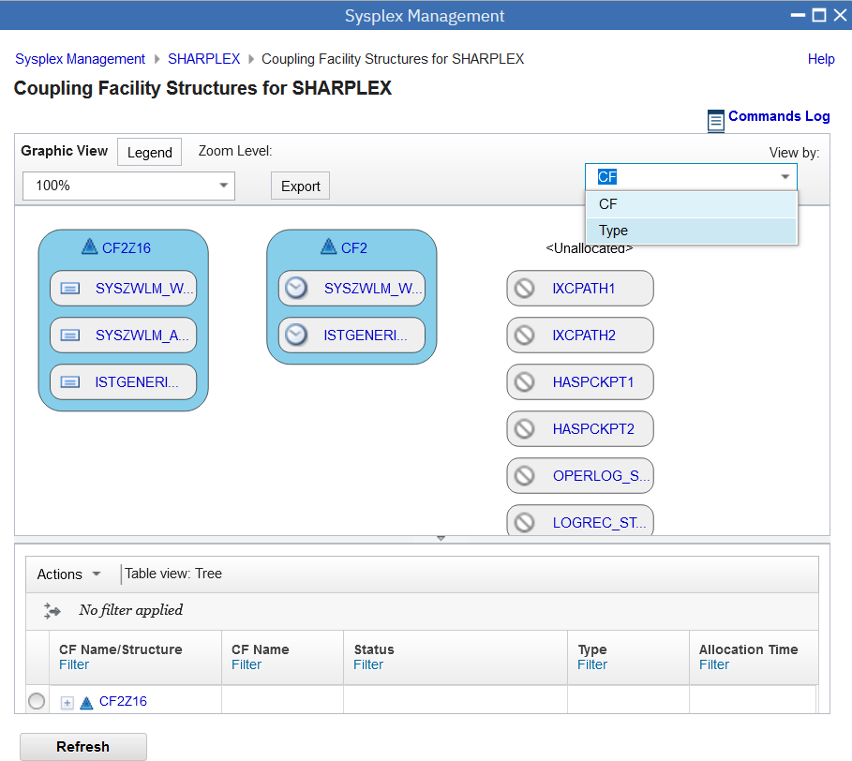

Use the Coupling Facility Structures by type view to see and manage your coupling facility structures. It includes a graphic and a table view.

The graphic view varies shows:

* Coupling facility structures grouped by type: List, Lock, Cache, or Serialized List.
* Unallocated coupling facility structures, which do not have a type. They are assigned a type when they are allocated.

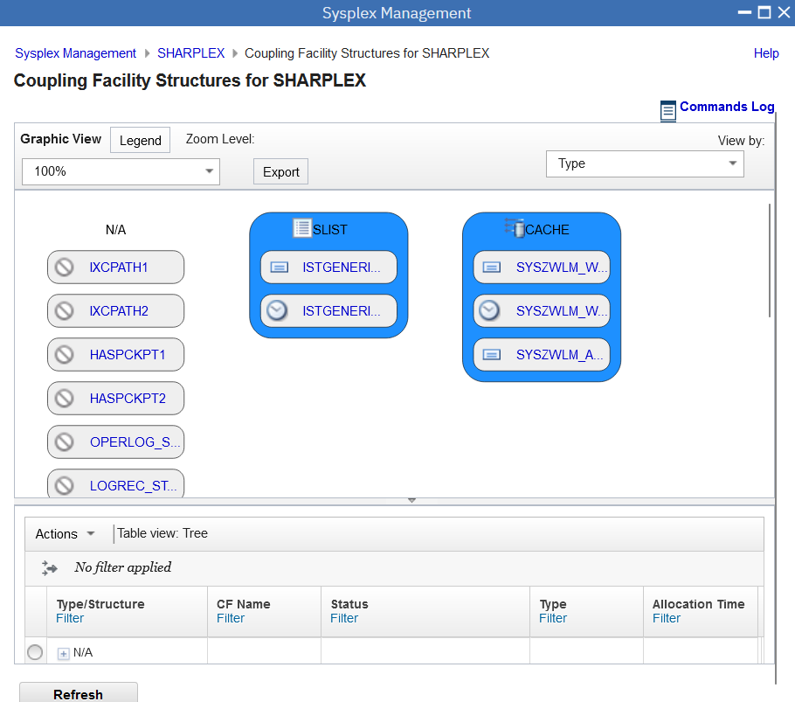

1. Access CF Connectivity View of Sysplex

Move cursor to breadcrumb on the top, click sysplex name **SHARPLEX** to go back to **Physical View of Sysplex**



In the Physical View, move cursor to the right top, click **View by** drop down, select **CF Connectivity**, then you will go to **CF Connectivity View of Sysplex.**

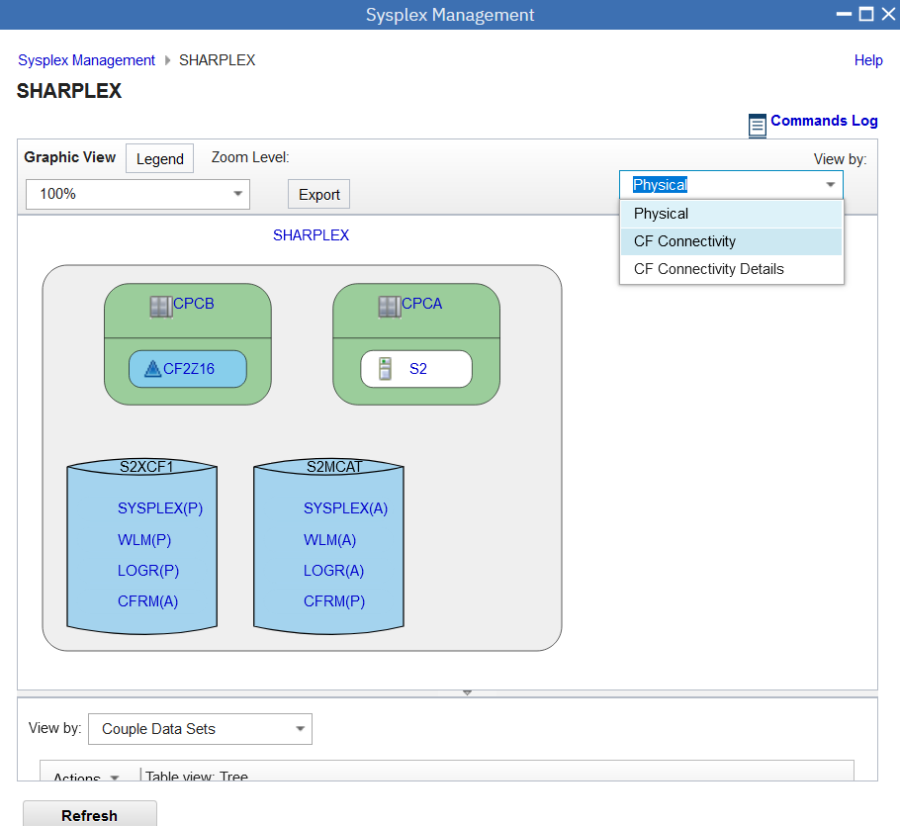

Use the CF Connectivity view to view and manage physical connections among systems and CFs. The CF Connectivity view includes a graphic view and a table view.

CPCs are represented by objects containing z/OS systems (a number in parentheses indicates the number of z/OS systems) and coupling facilities. Physical connections are shown as lines. The number of physical connections is shown in a box on the line connecting CPCs. 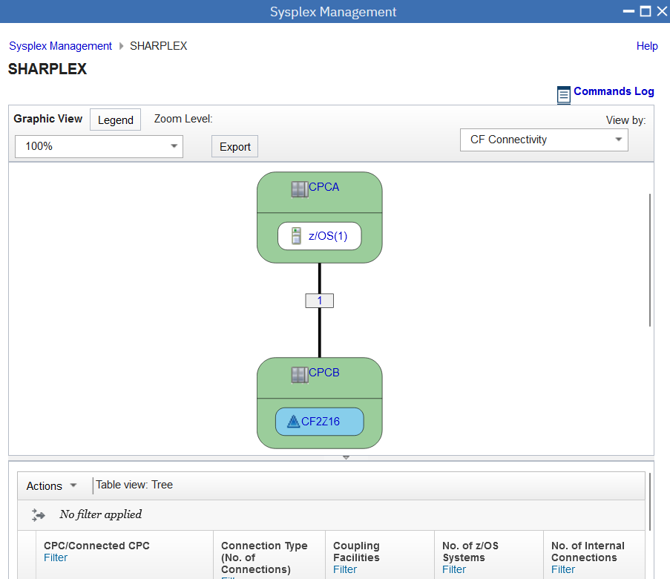

1. Access CF Connectivity Detail View of Sysplex

In Connectivity View, move cursor to the right top, click **View By** drop down, select **CF Connectivity Detail**  to open CF Connectivity Detail

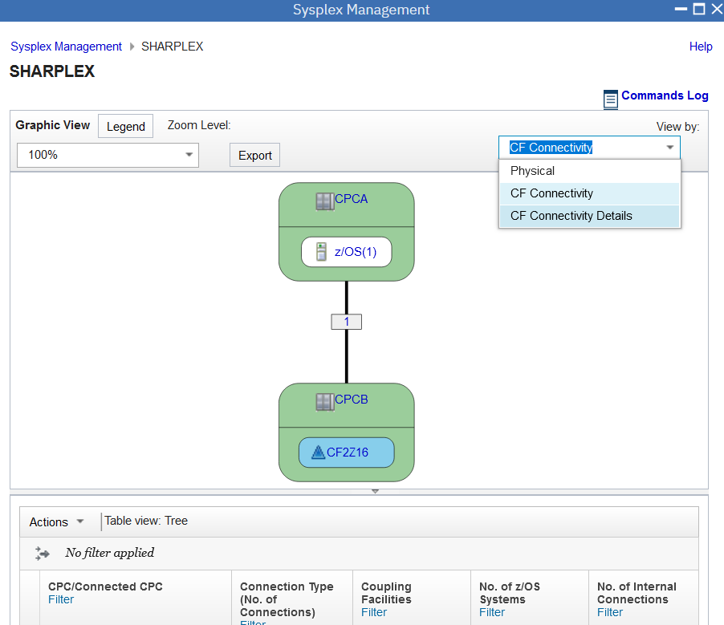

Use the CF Connectivity Details view to see details of connectivity between a CF and a system. Besides physical connections for the connectivity, it also shows which Channel Path Identifier (CHPID) and port are used for connectivity. The CF Connectivity Details view includes a graphic view and a table view.

The graphic view shows the sysplex as the largest object, containing CPCs, which in turn contain systems (S2 in the example) and CFs (CF2Z16 in the example). CHIPDs, adapters, and ports are represented to show the connection between systems and CFs. In the example, the CHPIDs are E0, and the adapters/ports are both N/A. 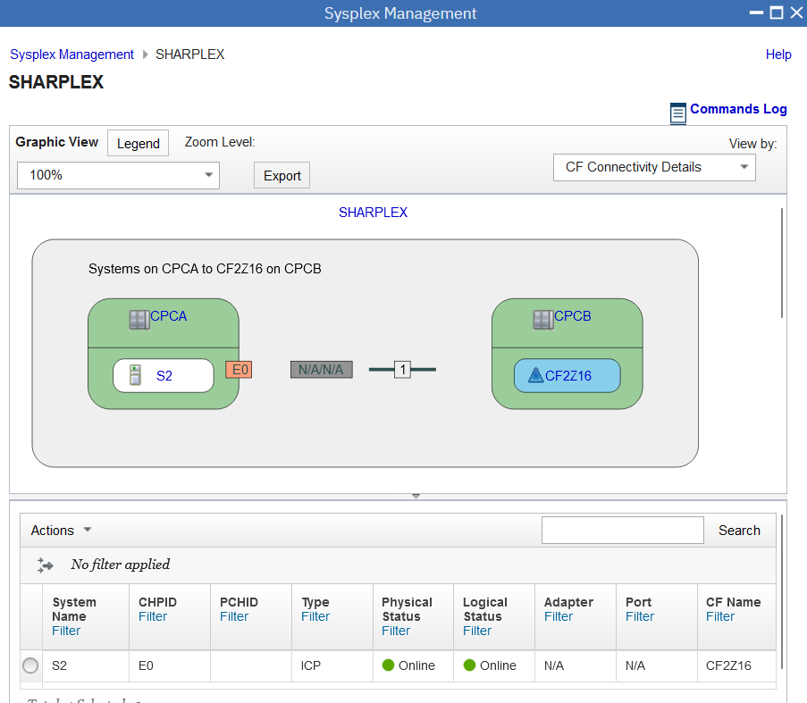

1. Check Command Log

In CF Connectivity Details View, move cursor to the right top, click **Commands Log**



Use the commands log to see and manage your sysplex commands performed by UI actions on Sysplex Management panels. All main views have the link to the commands log.

The commands log displays the commands used in sysplex management and their relationship between sysplexes, objects, and systems. It displays the status and output of each command, as well as the user that issued the command. The number next to commands log indicates how many commands have been updated or added since you last visited the commands log page. The commands that have been updated or added appear in bold type. Use the filter bar to search the commands table.

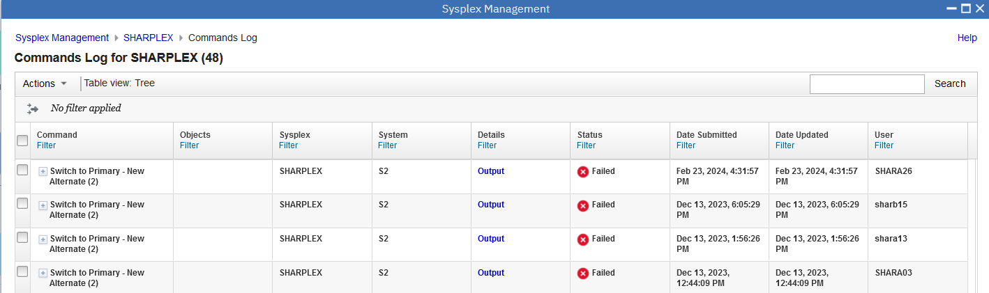

Move cursor to column **Detail**, click one blue **Output** to view detail output.

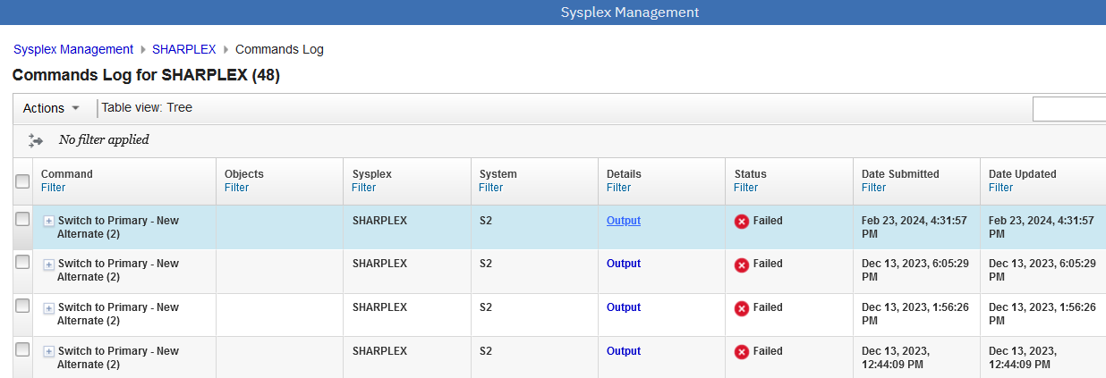

Use the Commands Output to view the output of your command.The Commands Output page displays the console output of commands used in sysplex management.

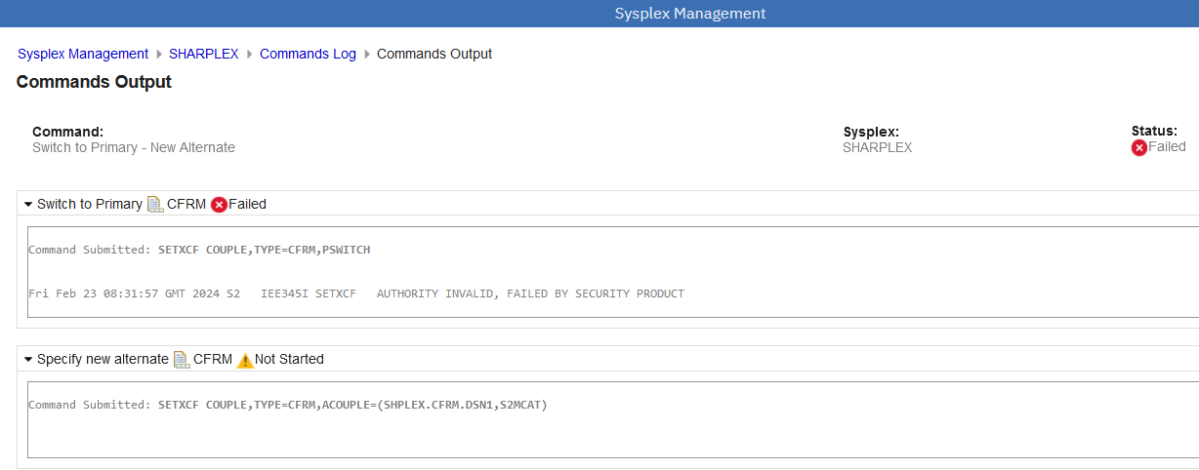

1. Switch Alternate to Primary

Move cursor to the top, click **Sysplex Management** in the breadcrumb to switch back to Topology View of Sysplex

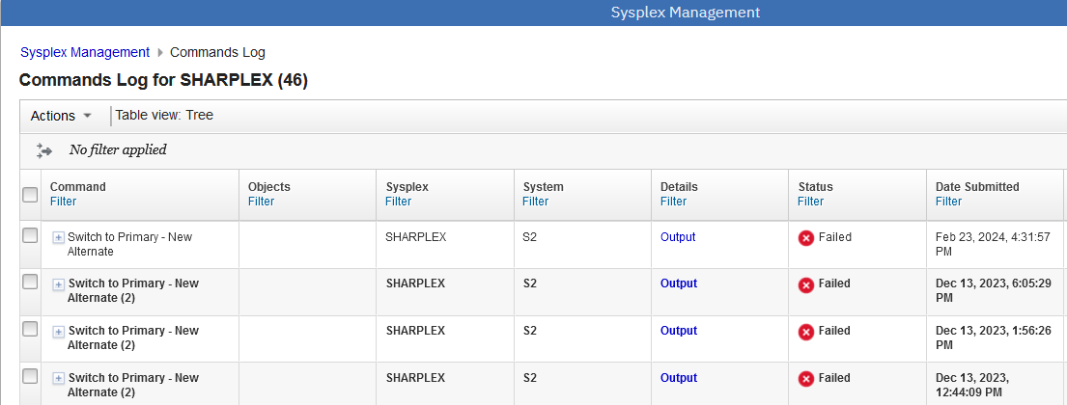

In the Topology View, click on the sysplex name **SHARPLEX** to open Physical View

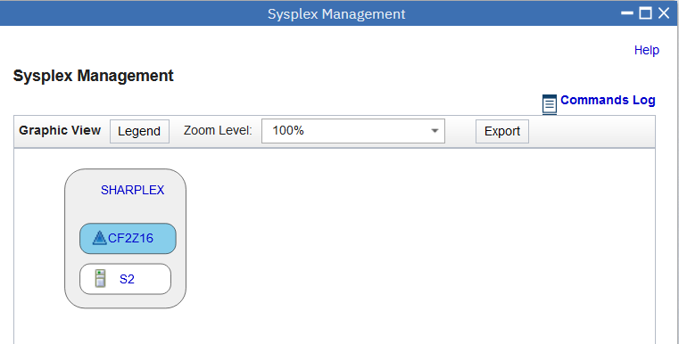

In the Physical View, right click on the couple data set **CFRM(A)**, select **Switch Alternate to Primary**, then select **New Alternate**

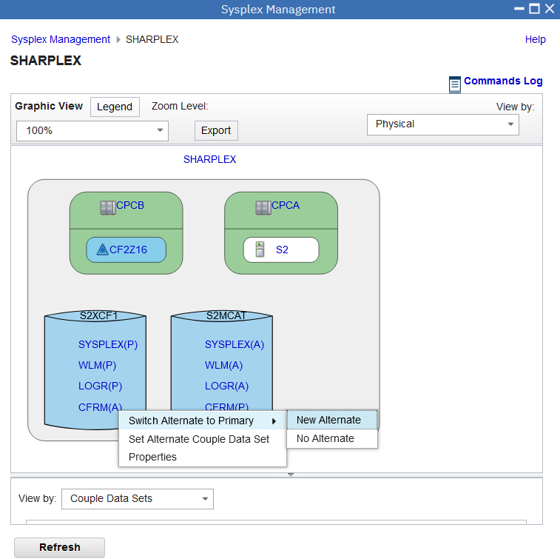

In the opened Confirm Switch Alternate to Primary dialog, input an available couple dataset **SHPLEX.CFRM.DSN1**, click **Search** button

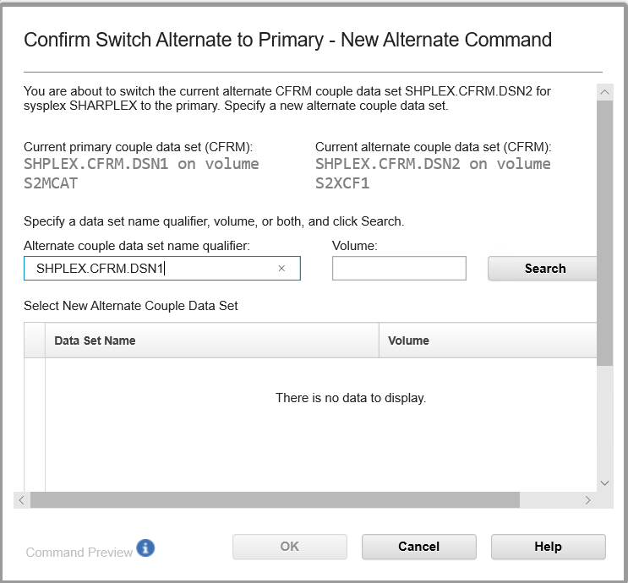

Click **the checkbox** of the new couple dataset in the table, then **Command Preview** on the left of OK button will be available. Click **Command Preview** to view the command.

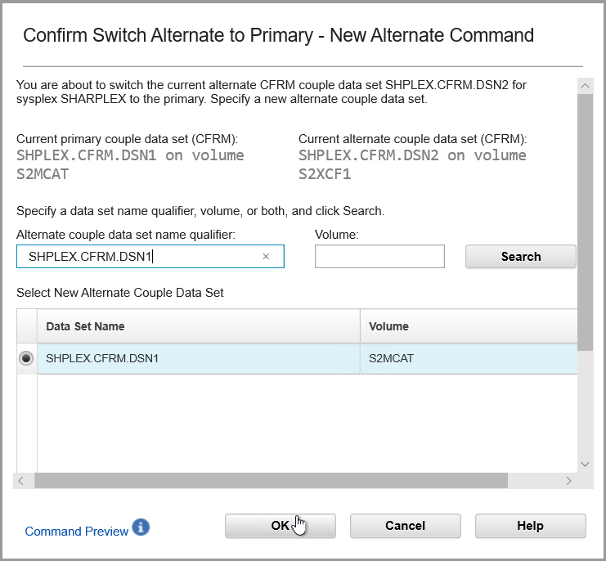

In the Command Preview dialog, you will see the command detail. Click **Close** to close it.

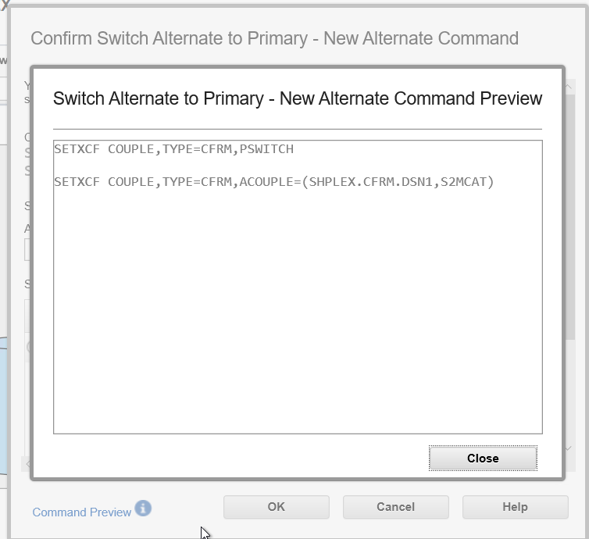

Then click **OK** to submit the command.



The operation will be failed because **the lab user does not have such authority.**

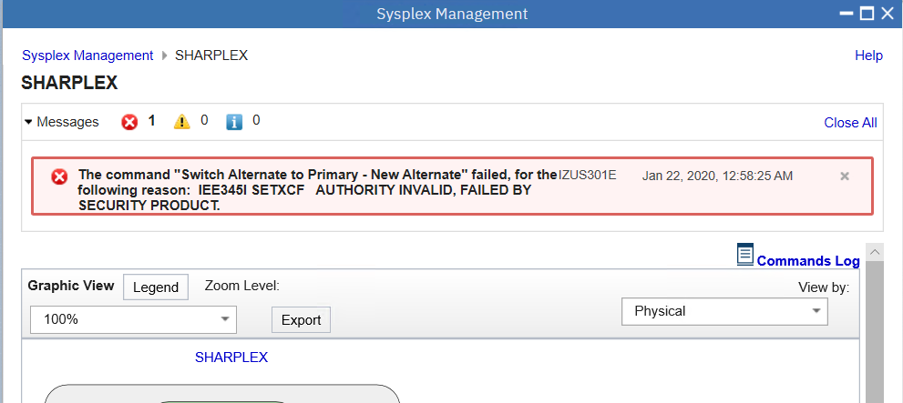

**The following is a sample snapshot if the operation can be done successfully.** You can see CFRM primary couple dataset and alternate couple dataset is switched successfully.

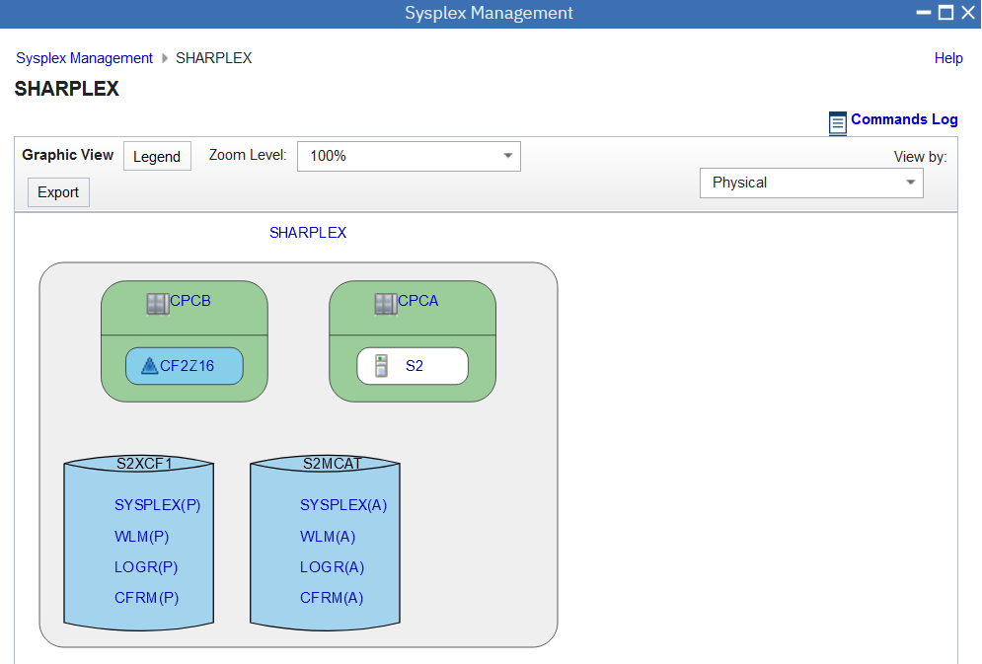

1. Check Warning icon

In the graphical view, single point of failure is indicated by a yellow warning icon () before a couple data set. Click on the warning icon can display details of the warning which could be, for example, no alternate couple data set is defined, or the primary couple data set and the alternate couple data set are in the same DASD volume.

In our lab system, all configuration is well done, therefore, there is no warning icon displayed on the graphic view. The following screen shots only **show you how the warning could look like**. **You don’t need to do any action for this step.**

For example, if no CFRM alternate couple data set is defined, there will be a warning icon in front of CFRM primary couple data as the below snapshot.

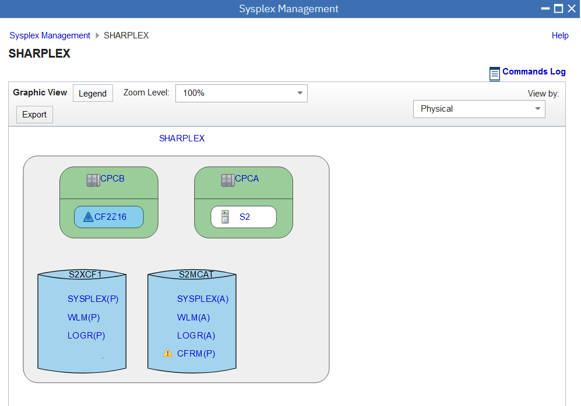

When you hover the warning icon, there is warning message popup.

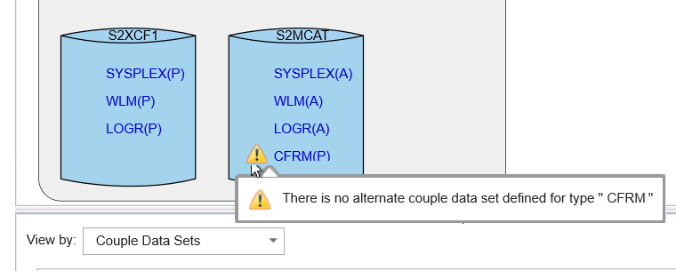

1. Check Notification

The Notifications page displays warning and error notifications associated with the sysplex.

The Sysplex Management task checks for the following conditions, and generates warning or error notifications as appropriate:

* Single point of failure for a couple data set
* Channel path is not online
* Coupling facility is in maintenance mode
* CPC is not configured correctly.

In our lab system, you might not see Notification on the graphic views. **The following screen shots are just examples for your reference**. **You don’t need to do any action for this step.**

For example, in current system, if there is no alternate CFRM couple data set, in Physical View, you can see a warning icon before primary CFRM couple data set. Click **Sysplex Management** in the breadcrumb to go to Topology View.



In Topology View, on the right top of sysplex, there is a bell icon, this bell icon is Notification mark, click **bell icon** to open Notification page.

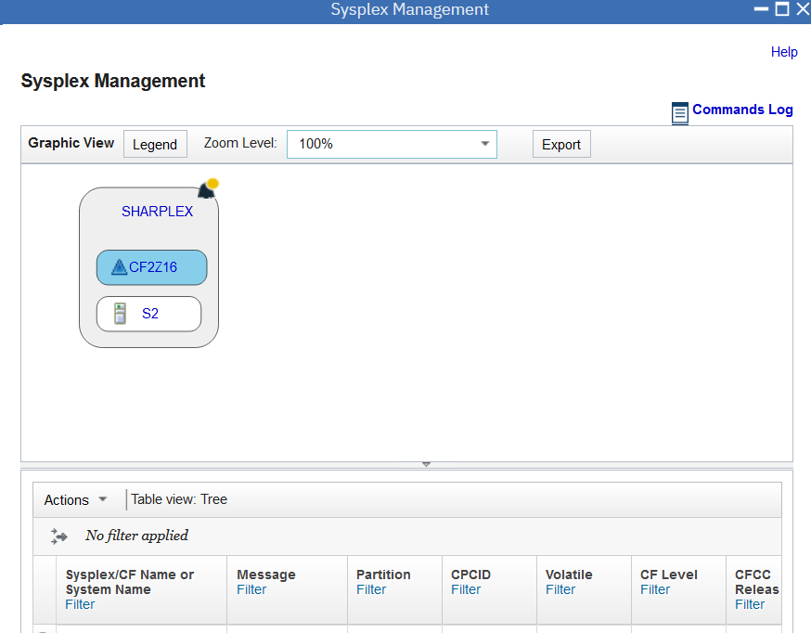

The notifications are displayed on the Notifications page, in a table. Click Message ID or Message, you can get some Help information.

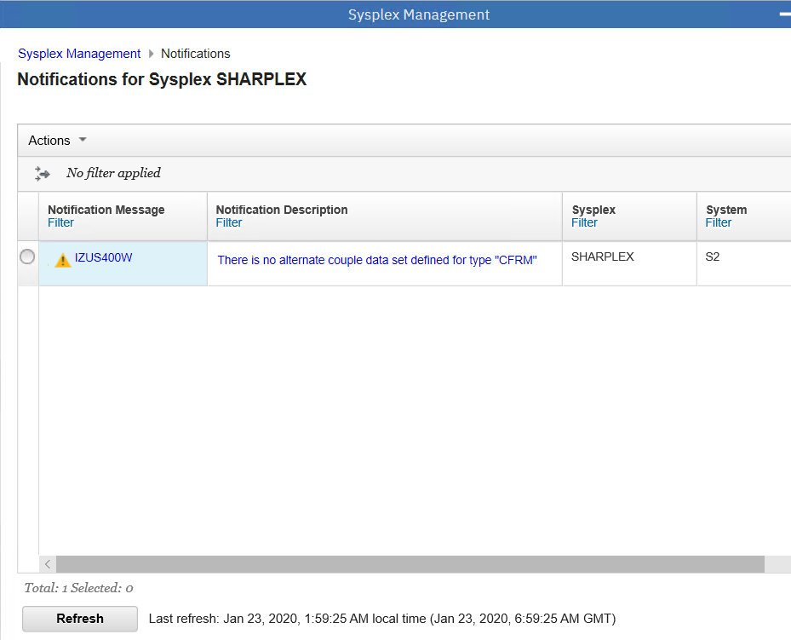

Click System Management link on the left top, it comes back to Topology View page.

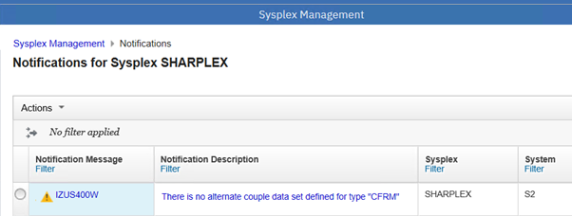

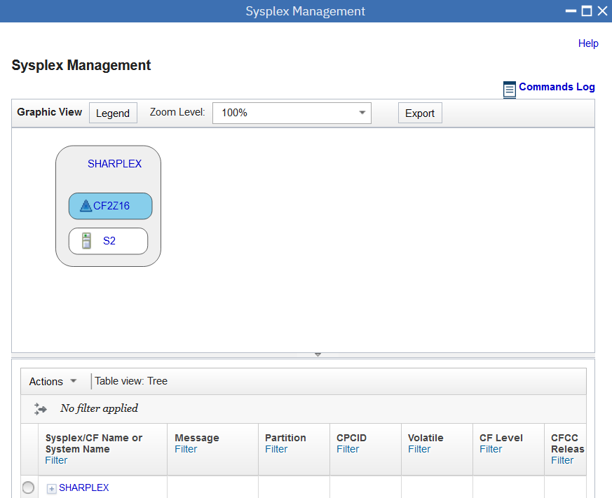

1. List CFRM Policies

In Topology View page, right click sysplex name, select **CFRM Policies** to open CFRM Administrative Policies page.

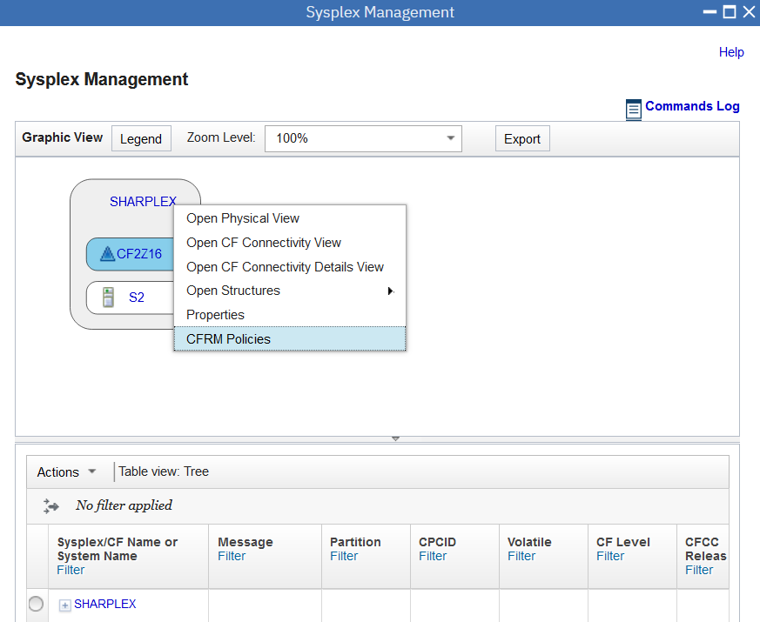

A coupling facility resource management (CFRM) policy describes the coupling facilities and structures that can be used in the sysplex. The CFRM policies reside in the active couple data set. From the CFRM Administrative Policies page, you can view and manage the CFRM policies for your sysplex. The page contains the CFRM Administrative Policies table.

Right click on policy “CFRMPOL1”

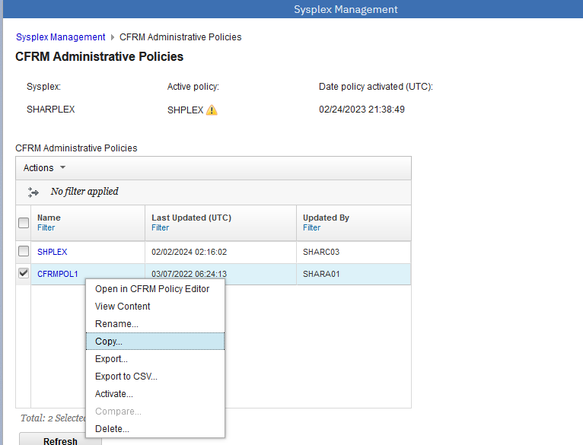

Select Copy, the dialog of Copy Administrative Policy will be opened. Input New Policy Name (although below screen shots used “POLICY1”, we recommend you to use “<userid>P”, in which <userid> should be replaced with your current logon user id), click **OK** button to submit it.

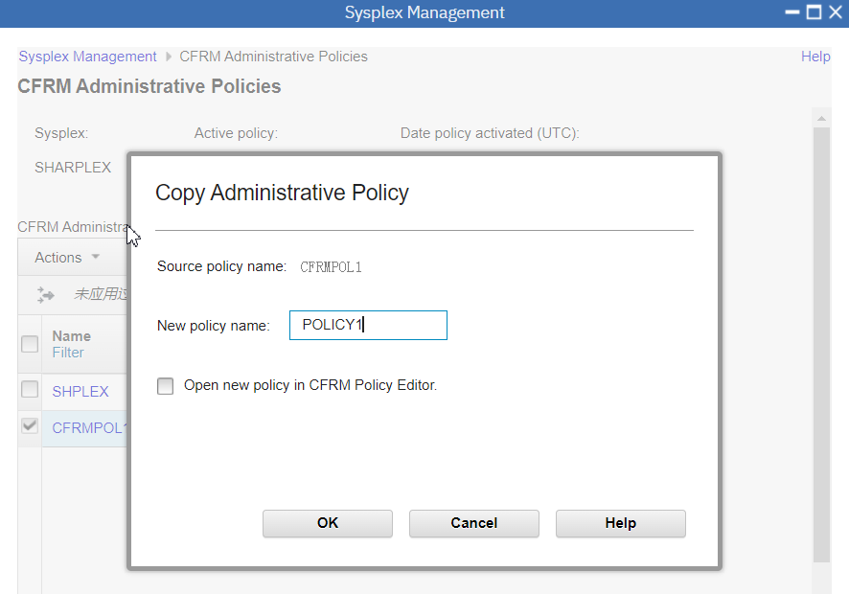

In the CFRM Administrative Policies page, you will see the copied policy “POLICY1”. Select **POLICY1** and another available policy in the list, click **Action** menu.

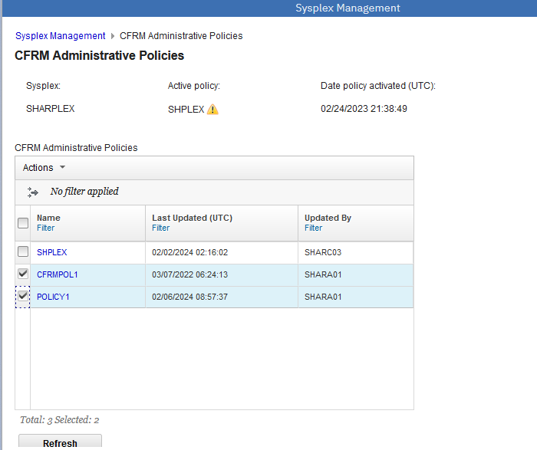

Click **Compar**e to open comparison tool to preview differences between two selected policies. This action is only enabled when exactly two policies are selected by the user.

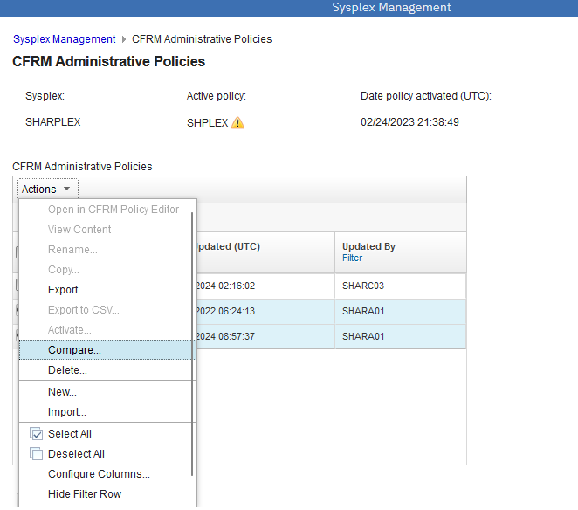

You can use this dialog to compare two CFRM administrative policies. The content of the Angular-based dialog is separated into two parts, which correspond to the two policies selected by the user. To view previous or next differences in the policies, click the arrows in the upper left corner of the dialog.

**Close** the dialog to return to the CFRM Administrative policies page.

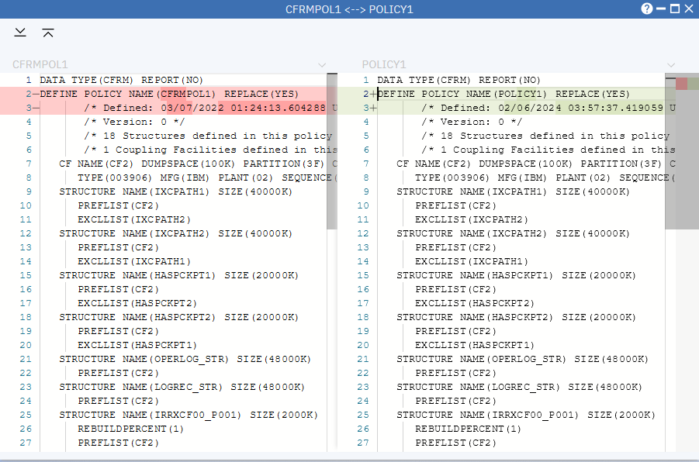

In the CFRM Administrative Policies page, select POLICY1, right click to open action menu. **Export to CSV** is to download two CSV files, one for Coupling Facility and one for Structure.

Since you are operating with a shared system, we won’t perform Export to CSV action.

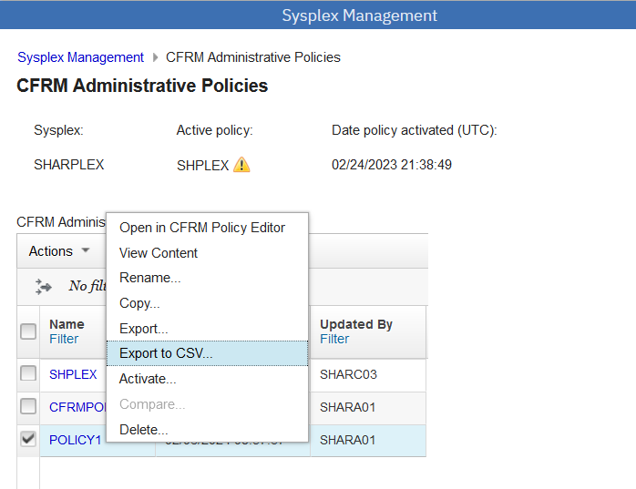

1. Work with CFRM Policy Editor

In the CFRM Administrative Policies, select policy “POLICY1”, right click to open action menu. Select **“Open in CFRM Policy Editor”,** CFRM Policy Editor is opened.

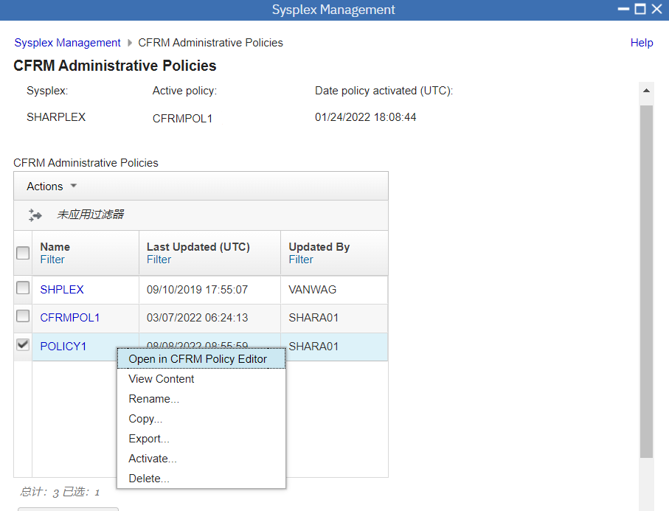

You can use the CFRM Policy Editor to modify the CFRM policies in the CFRM couple data set.

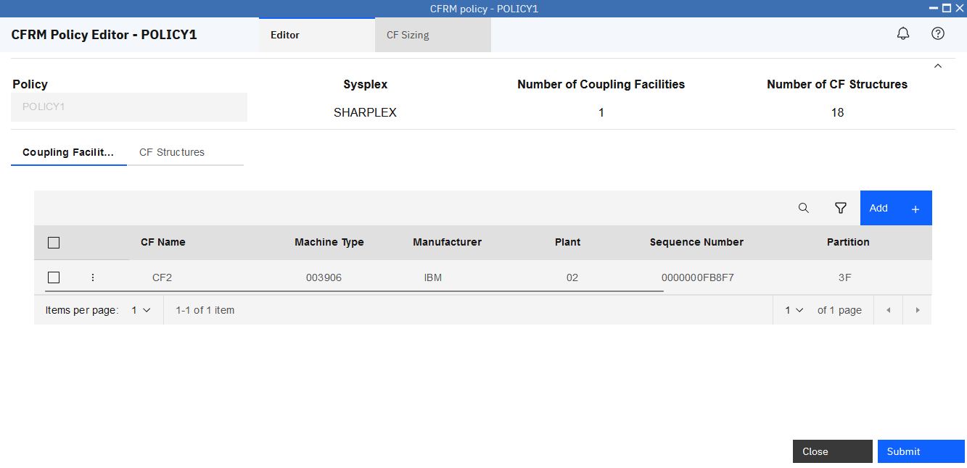

Click the action icon in front of a CF, open CF action menu, you can Modify, Rename, Copy and Delete a CF.

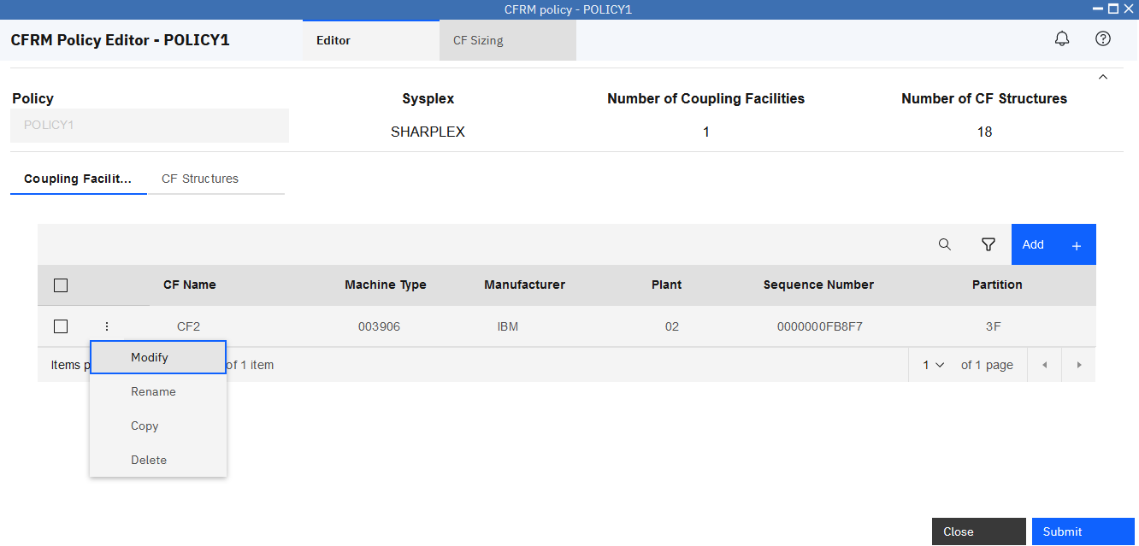

Move cursor to Modify, click **Modify**.



In Modify Coupling Facility CF2 page, you can update the value of CF. Since you are operating with a shared system, we won’t do any update. Please click **Cancel** to switch back to the CFRM Policy Editor.

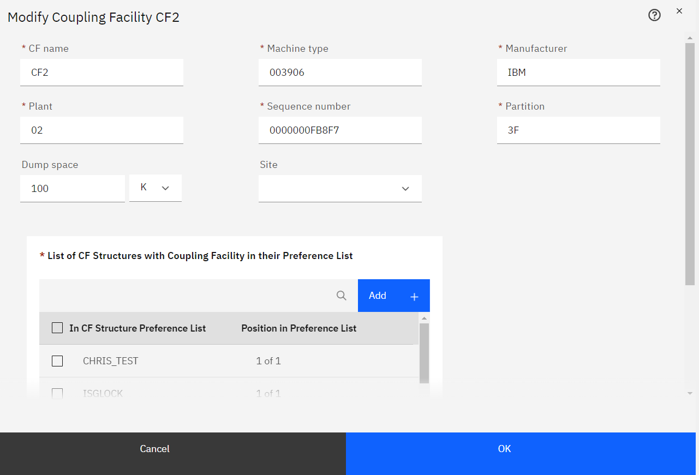

In CFRM Policy Editor page, you can click **Add** on the right top of the table, to Add a new CF.

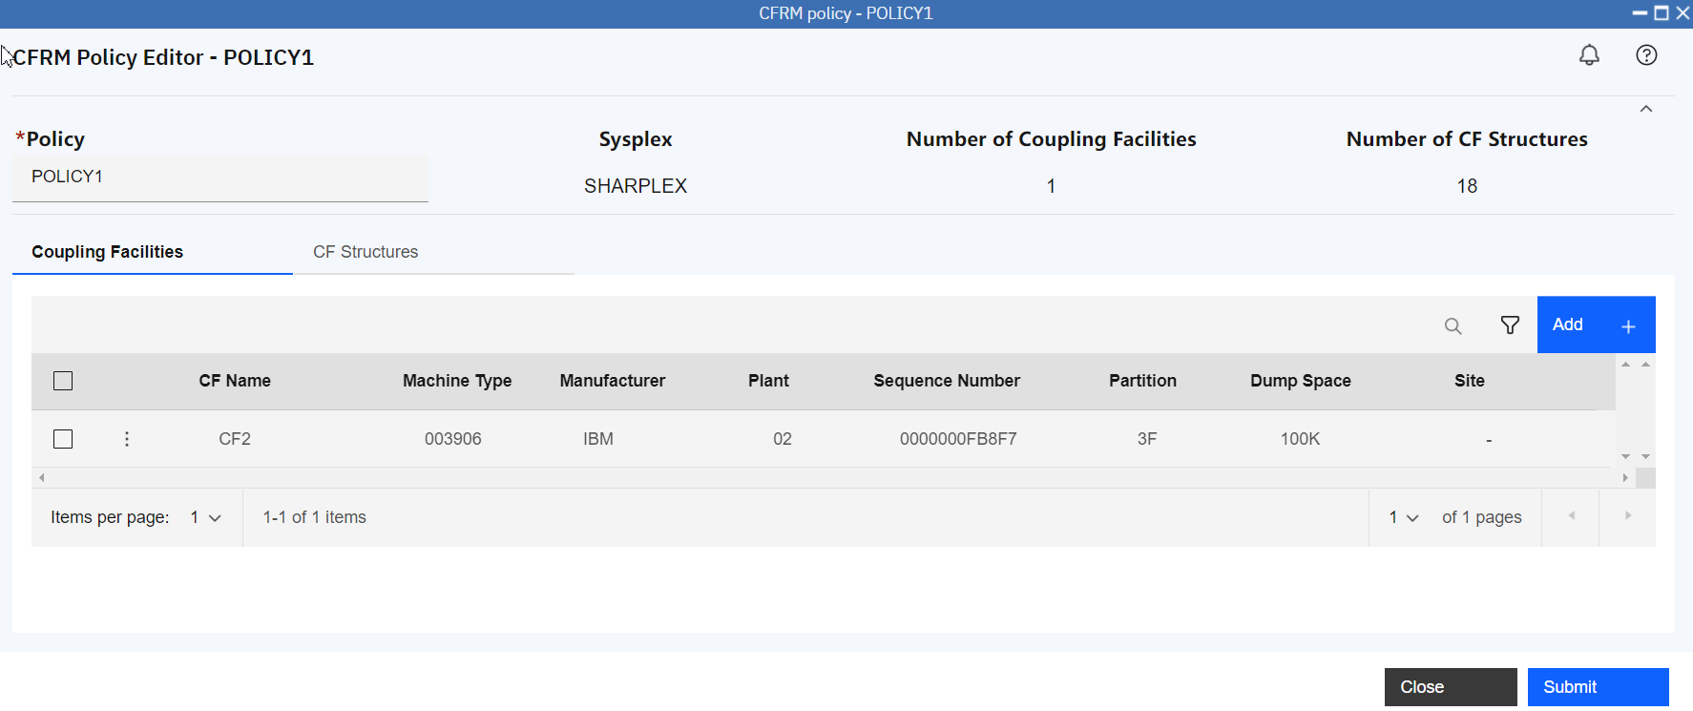

In Add coupling Facility page, you can input attribute value of CF. Again, please click **Cancel** to go back to CFRM Policy Editor as we don’t want to change the shared system.

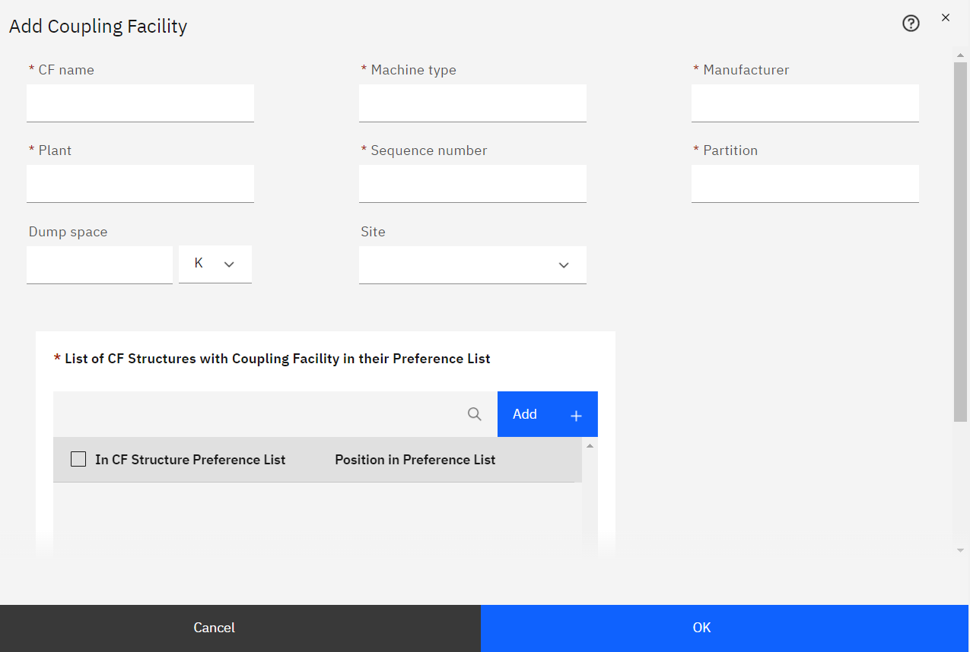

Now click tab **CF Structures** to open CF structures.



On CF Structures tab, you can add, edit, rename, copy, and delete CF structures for the selected CFRM policy. These actions are similar with the action in Coupling Facilities.

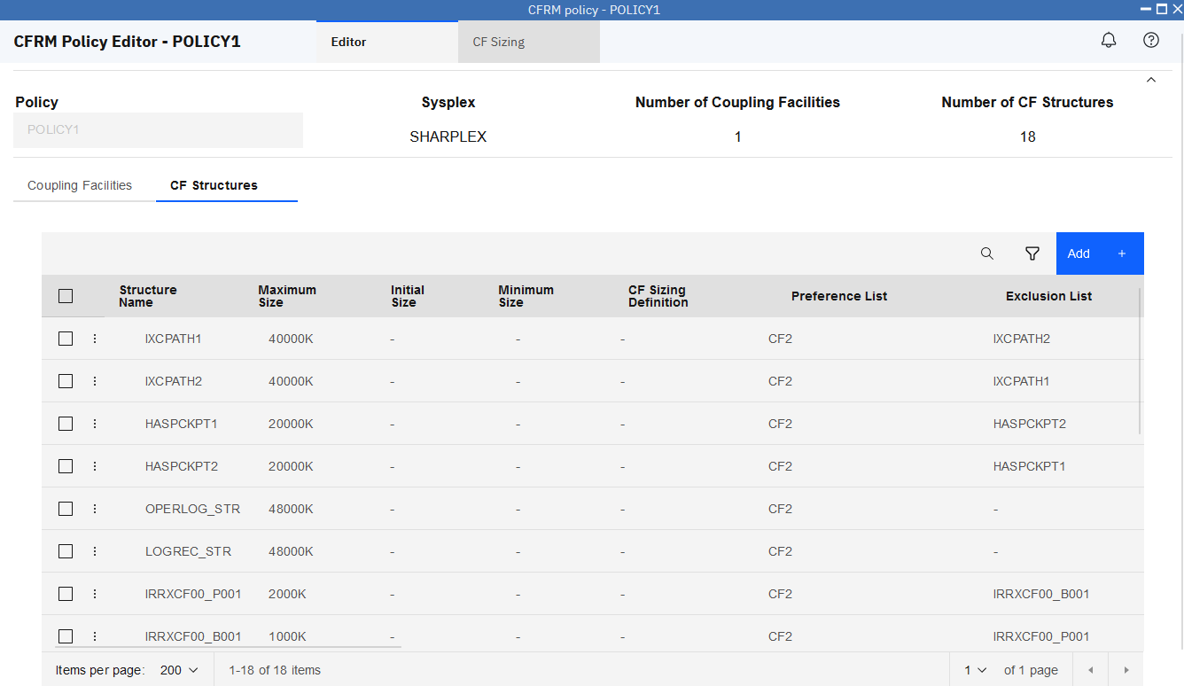

Click Search icon on the right top of the table to open Search.



In the Search field, input search condition, such as “ixc”, it gets searched result immediately.

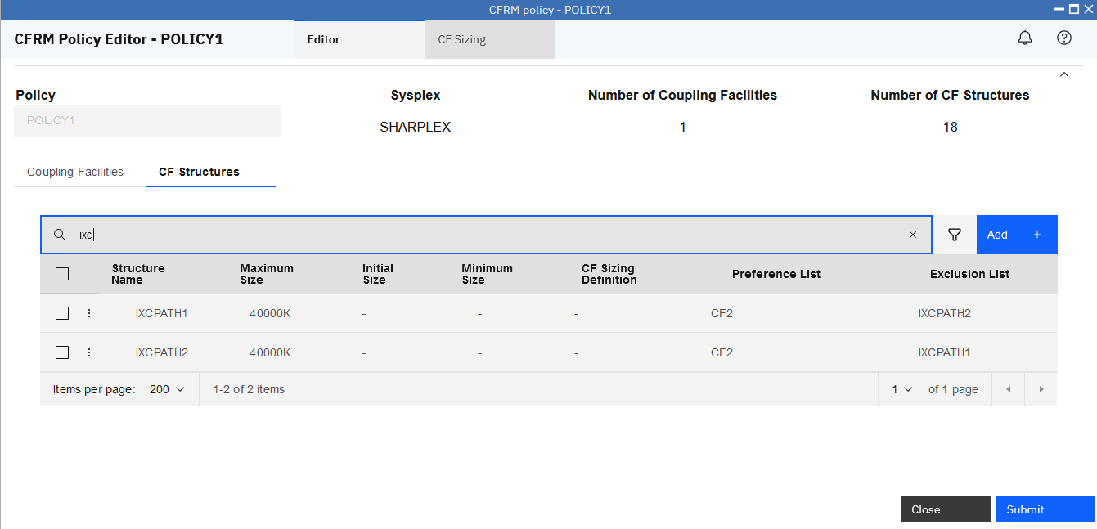

Select two structures in the table. Click **Modify** on the right top of the table to modify multiple CF structures at the same time.

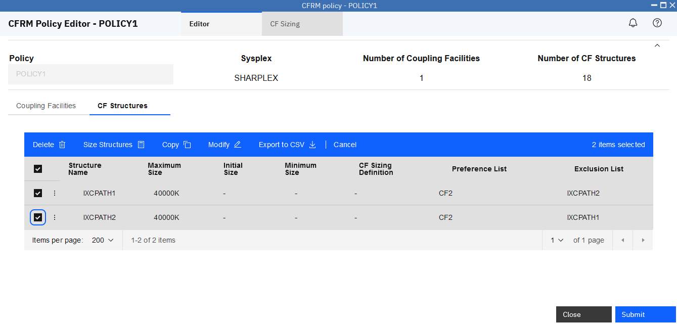

In the Modify Multiple CF Structures, enter values for the attributes that you want to modify. For example, input 5000 in Maximum size, then click **OK** to submit.

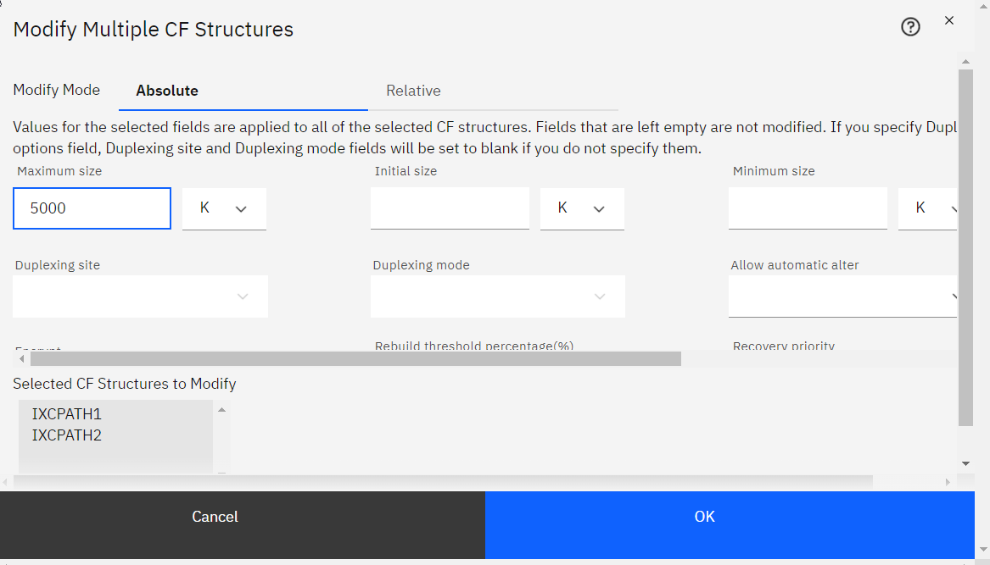

In the CF Structures table, the two Structures’ Maximum Size is updated.

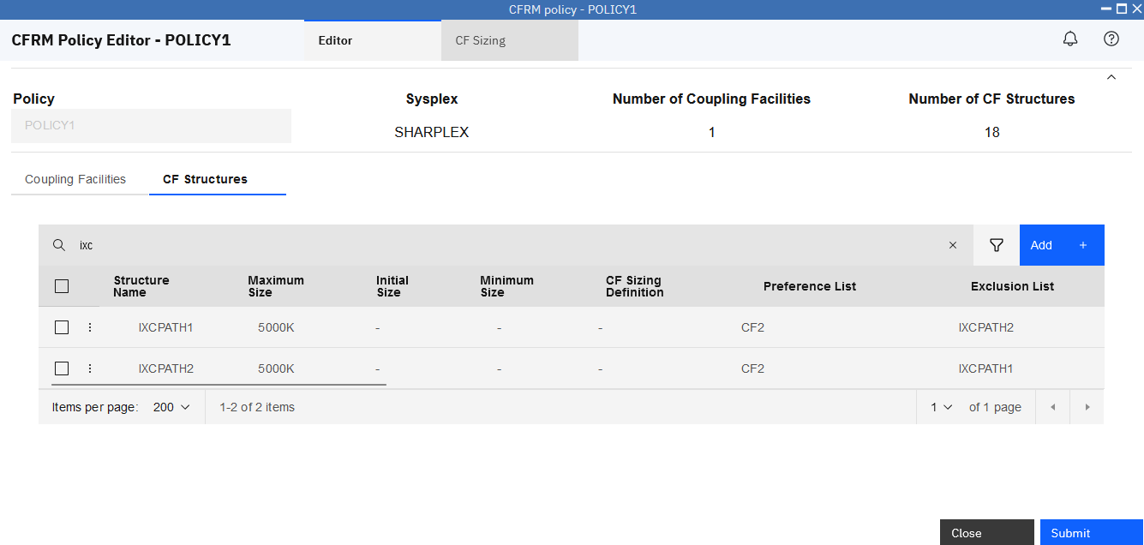

Select two structures, click Modify again.



In Modify Multiple CF structures page, select the Relative option, the attributes you modify can increase or decrease by the specified percentage. You can apply a relative change to individual fields or all of the selected fields.

Click **Relative** tab, input 10 in Maximum size, click **OK** to submit.

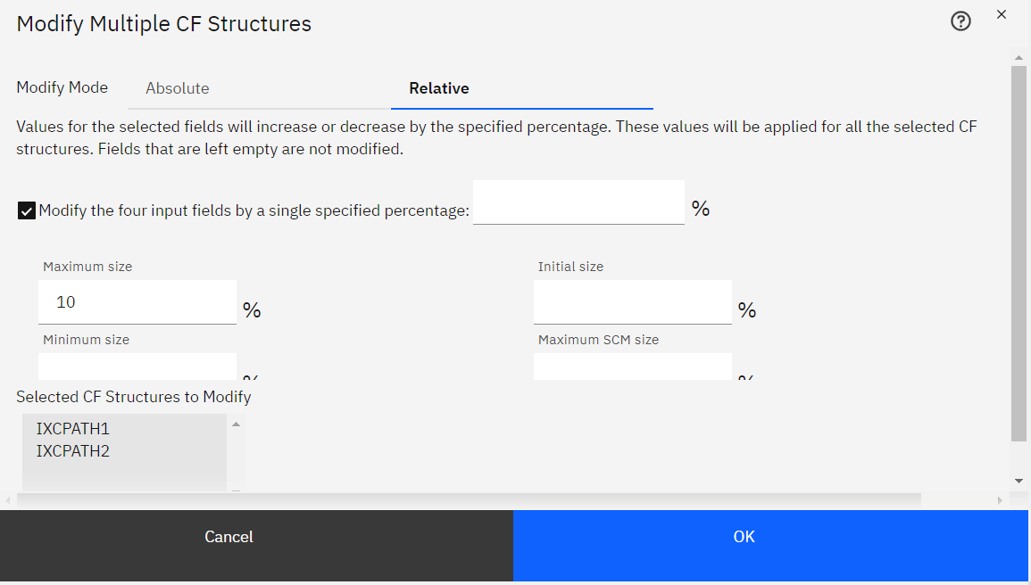

In the CFRM Policy Editor, you can see the Maximum Size is 5500K, increasing 10%.

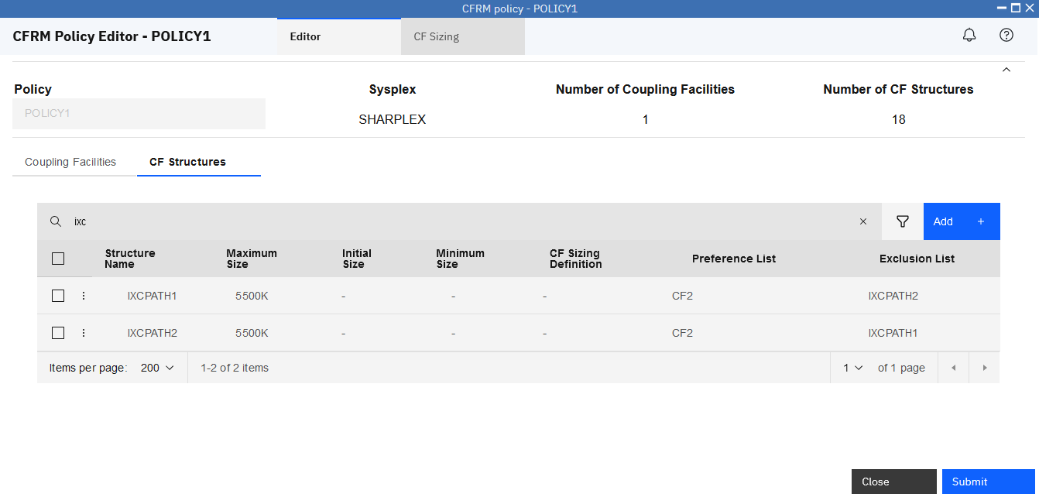

After you have done all update, **Submit** button can be used to save changes. Since you are operating with a shared system, we won’t perform Submit action.

1. Work with CF Sizing

In the CFRM Policy Editor page, click tab **CF Sizing** to open CF Sizing.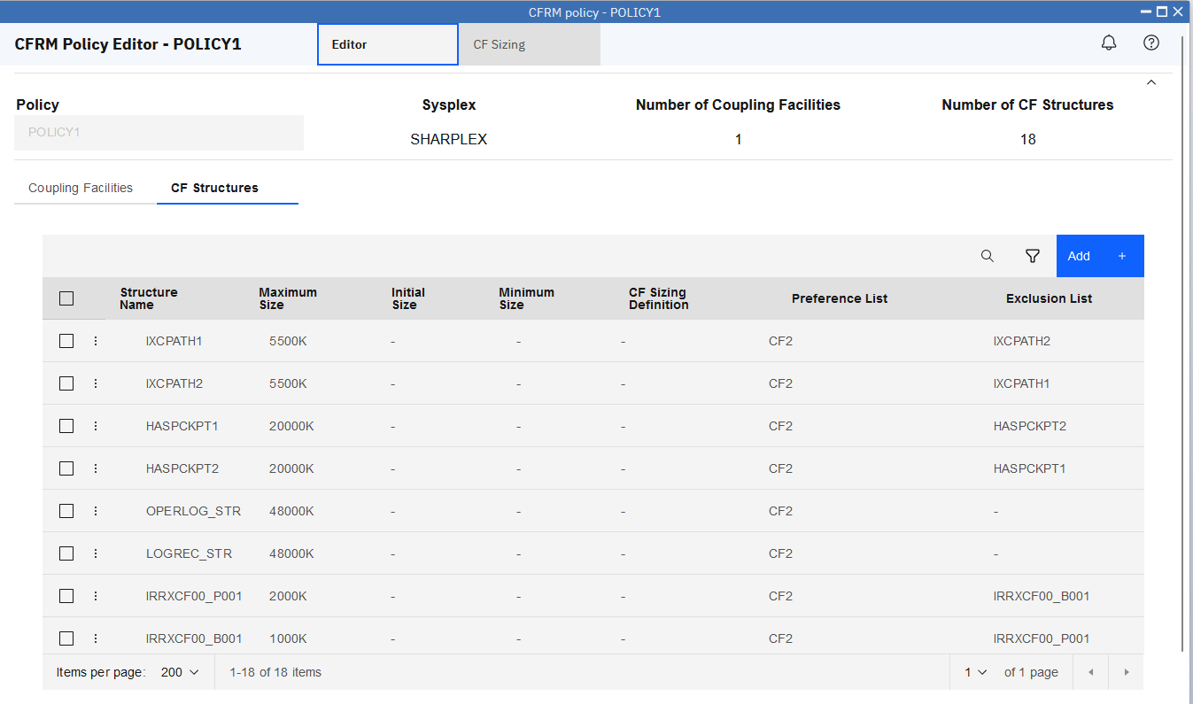

In the CF Sizing tab, click **Add** to add a Sizing Definition.

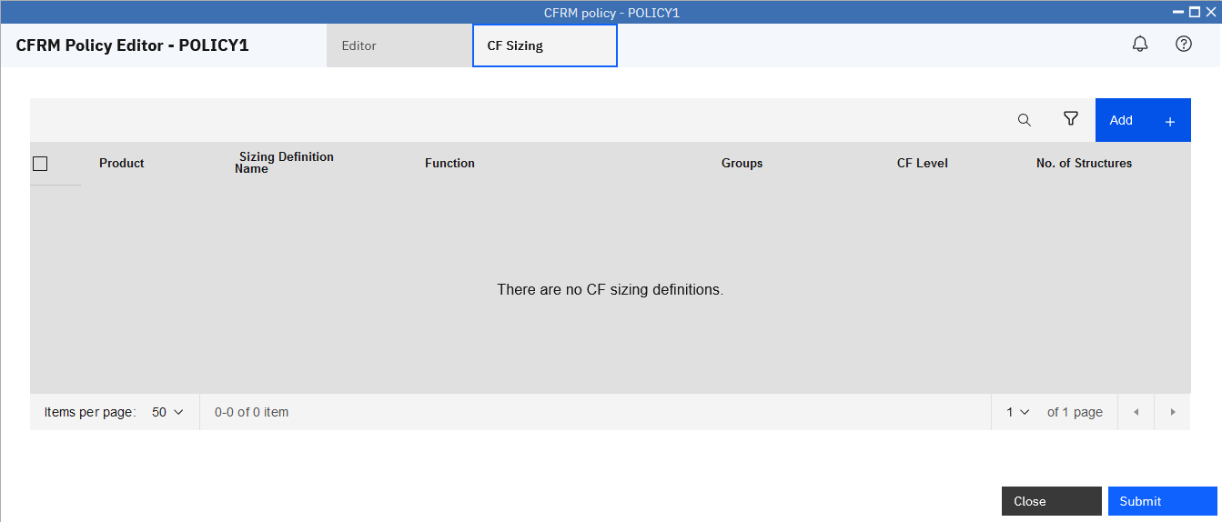

In the Add Sizing Definition, select **APPC** from Product dropdown list as Product.

Input new Sizing Definition Name (although below screen shots used “**SIZING1**”, we recommend you to use**“<userid>S**”, in which **<userid>** should be replaced with your current logon user id). Sizing Definition Name is a unique field. You can input another value if it has existed.

Select one available value from the dropdown list as CF Level (although below screen shots used **25**, the system may have different available CF Levels).

Select **APPC log structure** as Product Function, click **Calculate.**

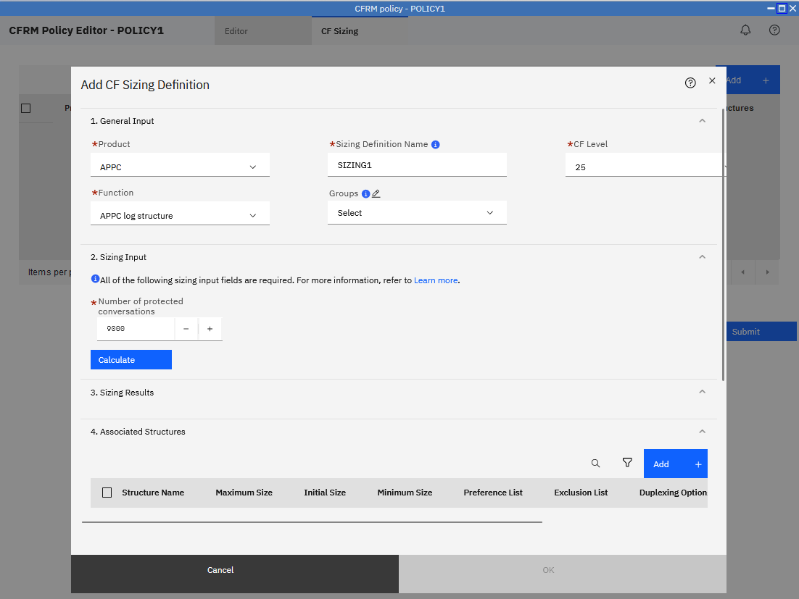

Then, you can view Sizing Results. Click button **Add** to add associated structures.

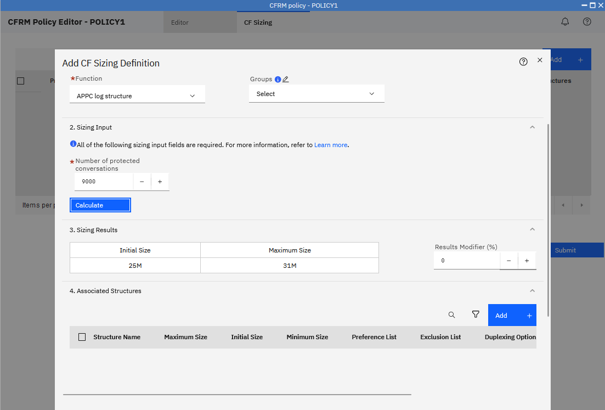

In the Add Associated Structures to Upgrade Sizing Definition, select two structures, click **Add**.

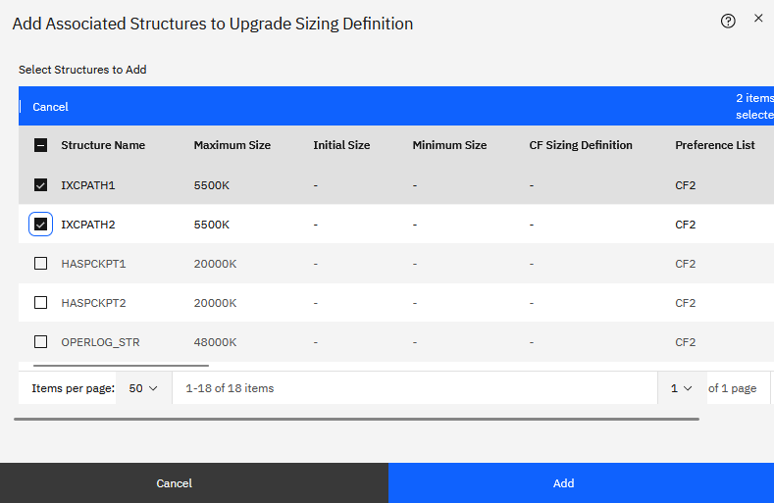

In the Add CF Sizing Definition, two structures are associated with the sizing definition. Click **OK**.

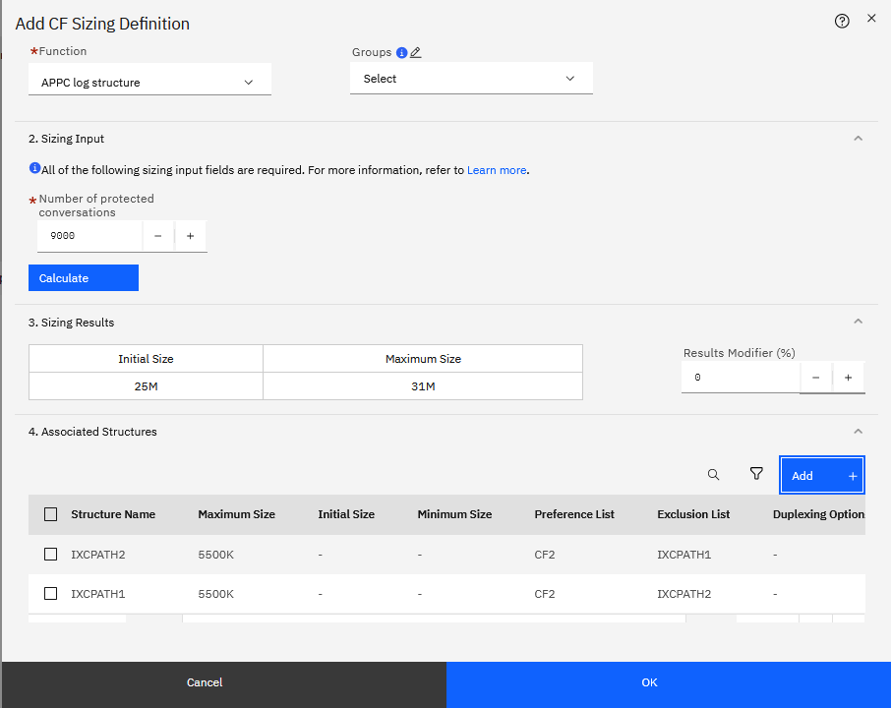

In the Size Structures with Sizing Definition SIZING1, click **OK**.

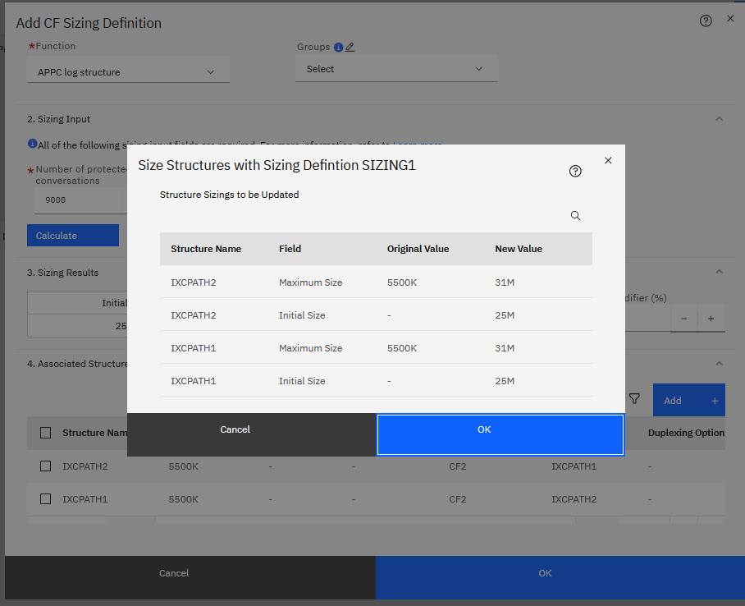

In the CFRM Policy Editor, CF Sizing named SIZING1 is showed in table.

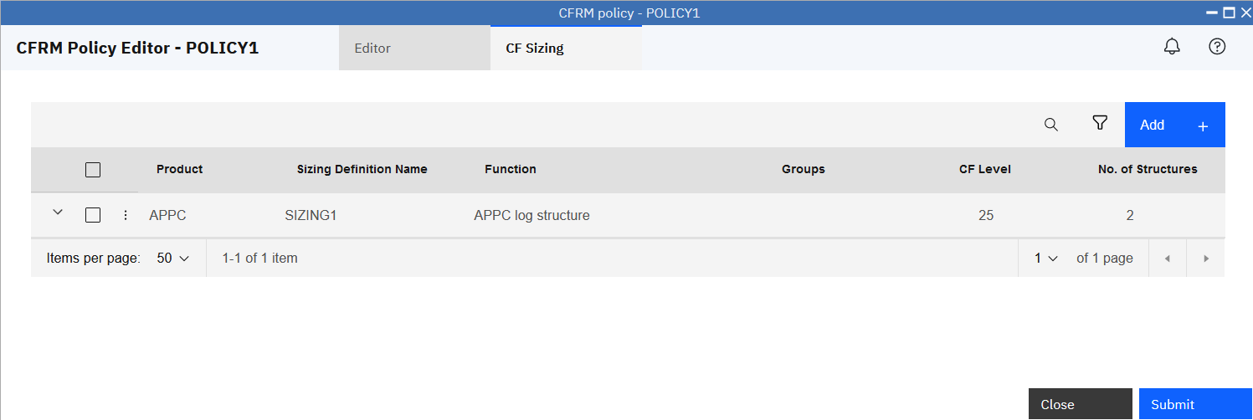

Click **Editor** tab, then click **CF Structures** tab, you can see the CF Sizing Definition attribute value of the two structures are SIZING1.

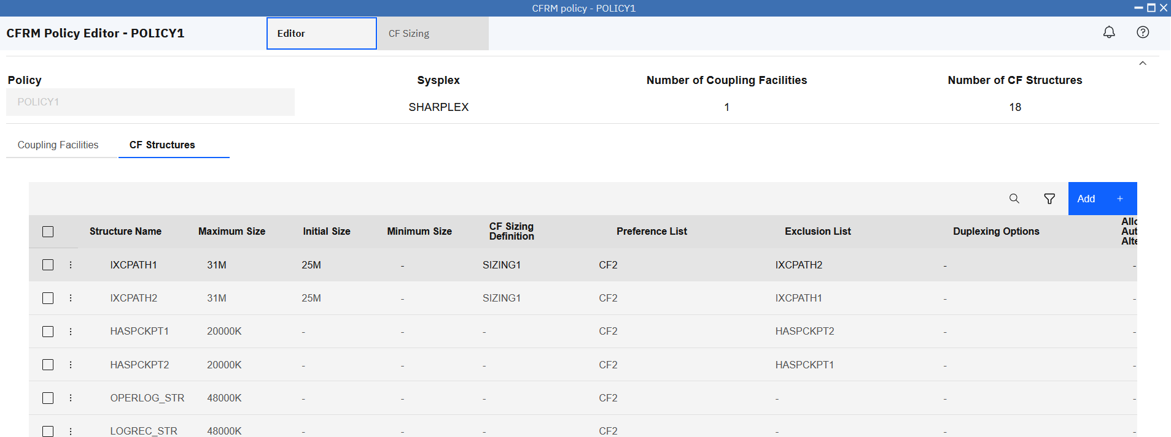

After you have done all update, **Submit** button can be used to save changes. Since you are operating with a shared system, we won’t perform Submit action.

Click **CF Sizing** tab of CFRM Policy Editor, click the action icon in front of a CF sizing definition, open action menu, you can Modify and Size, Copy, Remove Association and Delete a CF sizing definition.

Move cursor to Modify and Size, click **Modify and Size**.

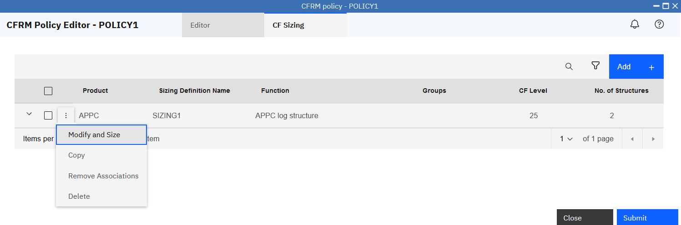

In the Modify SIZING1 Sizing Definition, you can modify the attributes of sizing definition SIZING1.

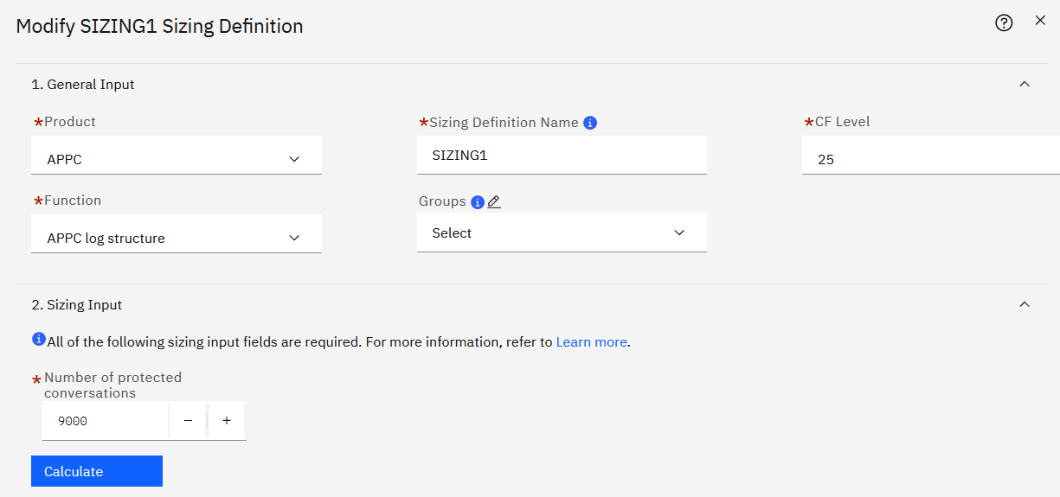

Click Product to open the dropdown list, move cursor to CICS, click **CICS.**

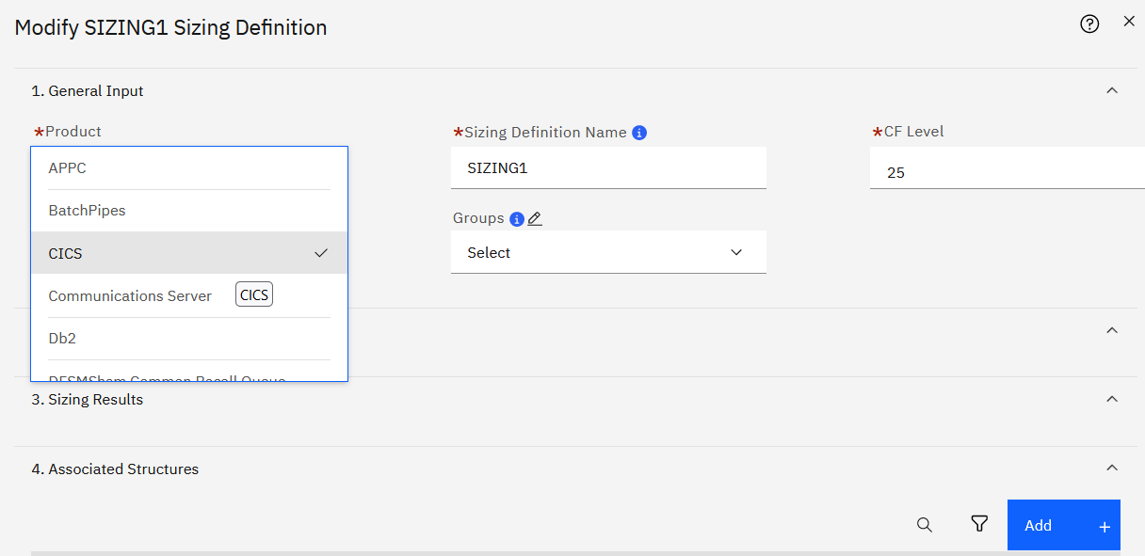

Click Function, in the dropdown list, move cursor to click **CICS Named Counter list structure**.

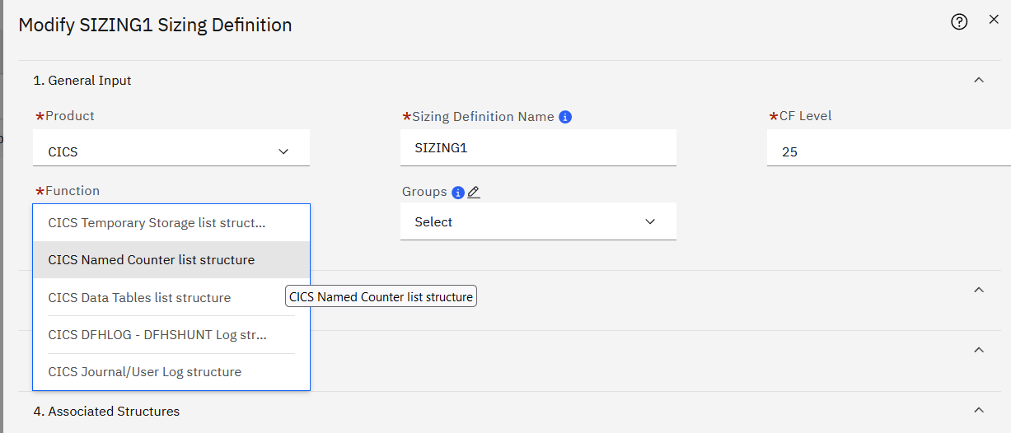

Click **Calculate.**

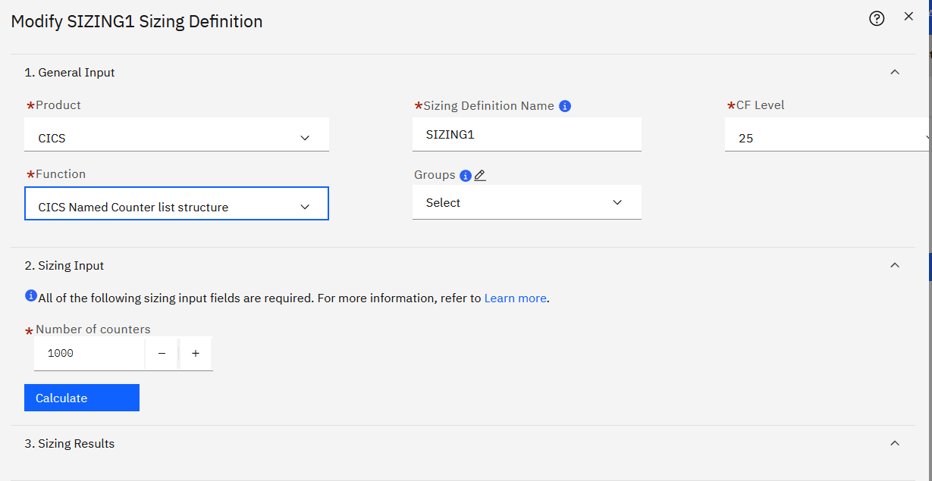

You can view the Sizing Result.

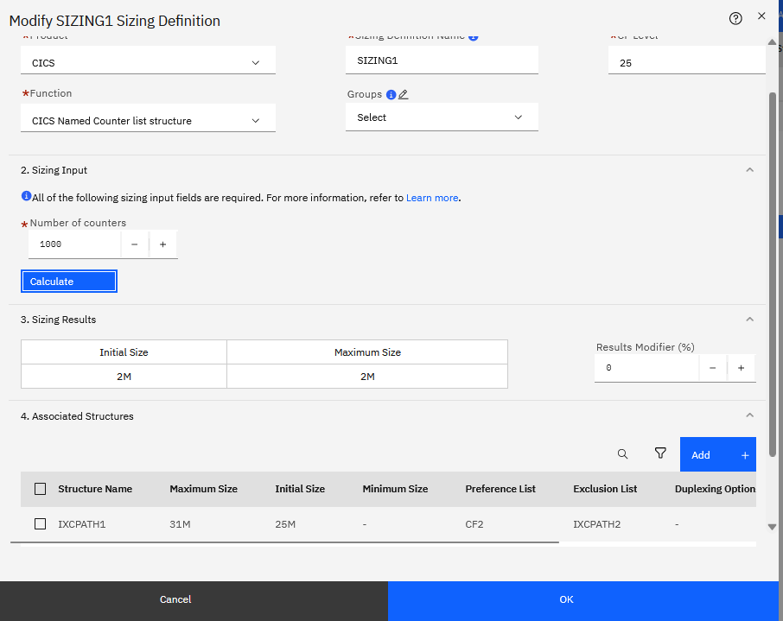

Move Cursor to Results Modifier. Set Results Modifier value as **100**, the Sizing Results are amplified by 100%. Click **OK**.

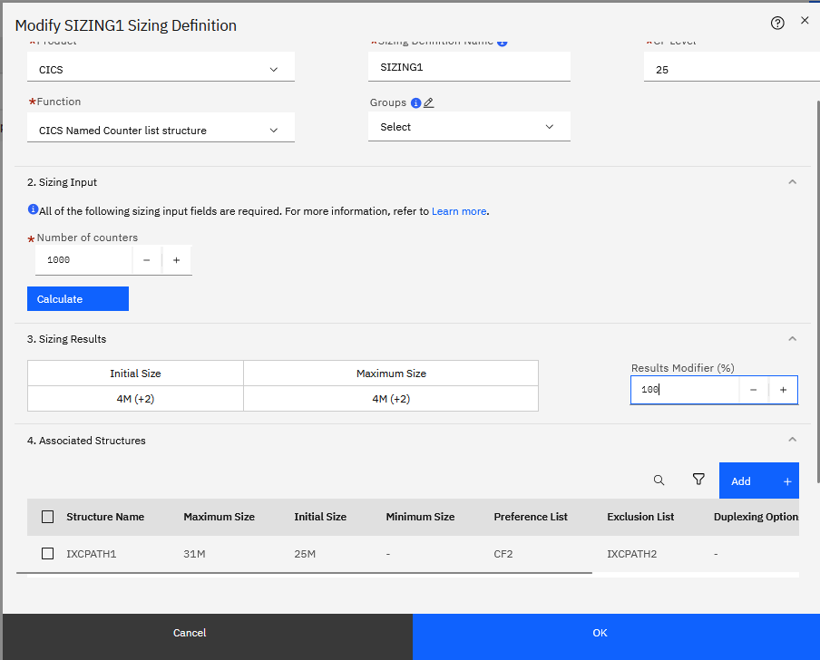

In the Size Structures with Sizing Definition SIZING1, you will see a warning icon which notes that the sizing of selected CF Structures is being reduced. Click **OK**

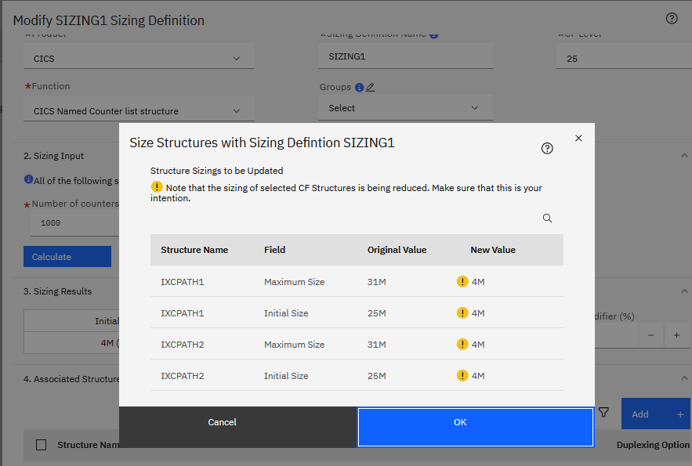

In the CFRM Policy Editor, the CF sizing definition is showed with updated result.

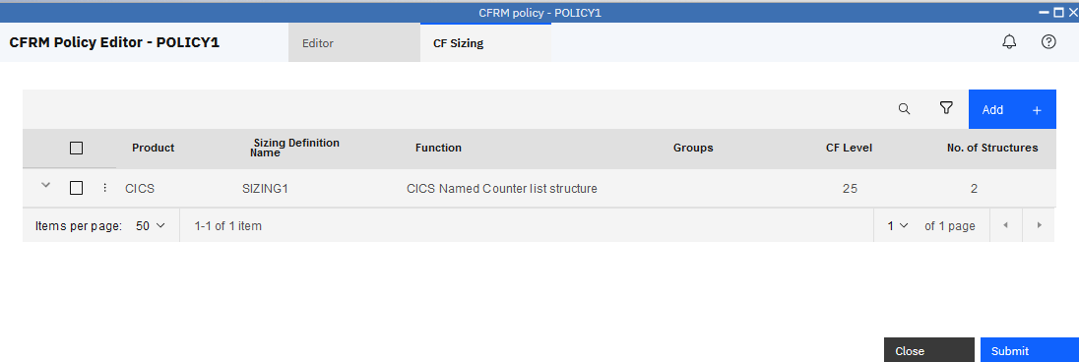

After you have done all update, **Submit** button can be used to save changes. Since you are operating with a shared system, we won’t perform Submit action.

In the CF Sizing tab of CFRM Policy Editor, click the action icon in front of a CF sizing definition, open action menu, move cursor to Copy, click **Copy**.

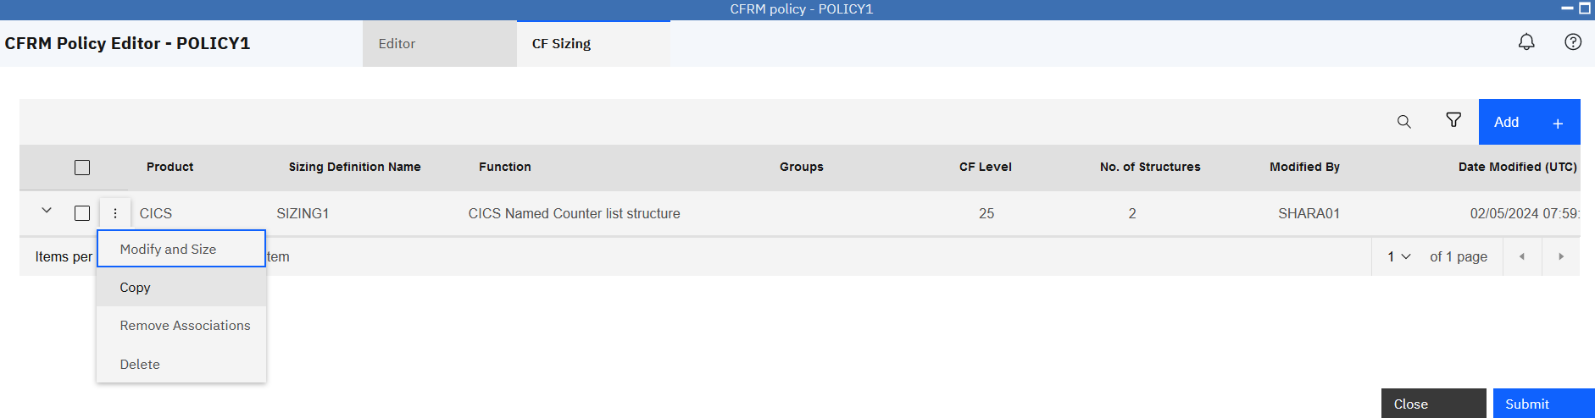

When you copy a CF sizing definition, all fields from the General Input and Sizing Input sections are copied over to the new CF sizing definition.

The associated CF structures from the copied CF sizing definition are brought over, since a CF structure can be associated with only one CF sizing definition.

The default Sizing Definition name is **SIZING1_COPY**, you can input one unique name.

Click **OK** to create the copied CF sizing definition and update the associated structure,

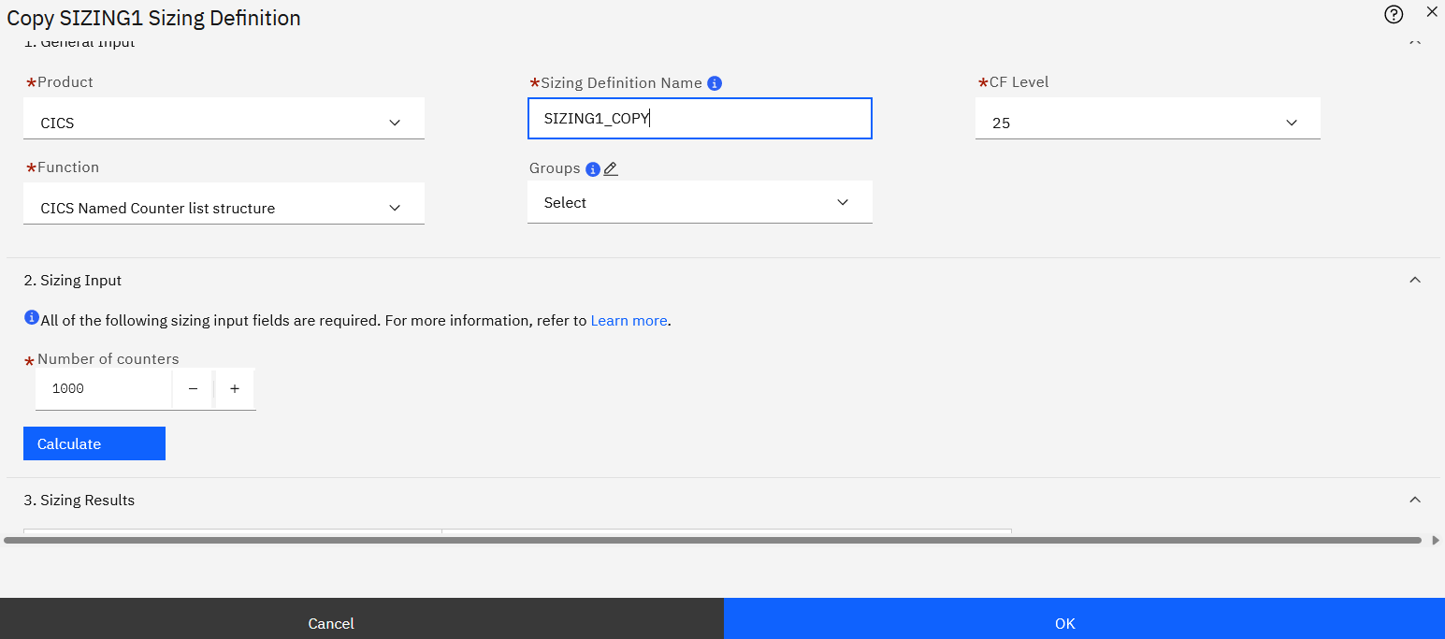

On completion, the CF Sizing Definitions table is displayed, showing the new CF sizing definition named **SIZING1_COPY**.

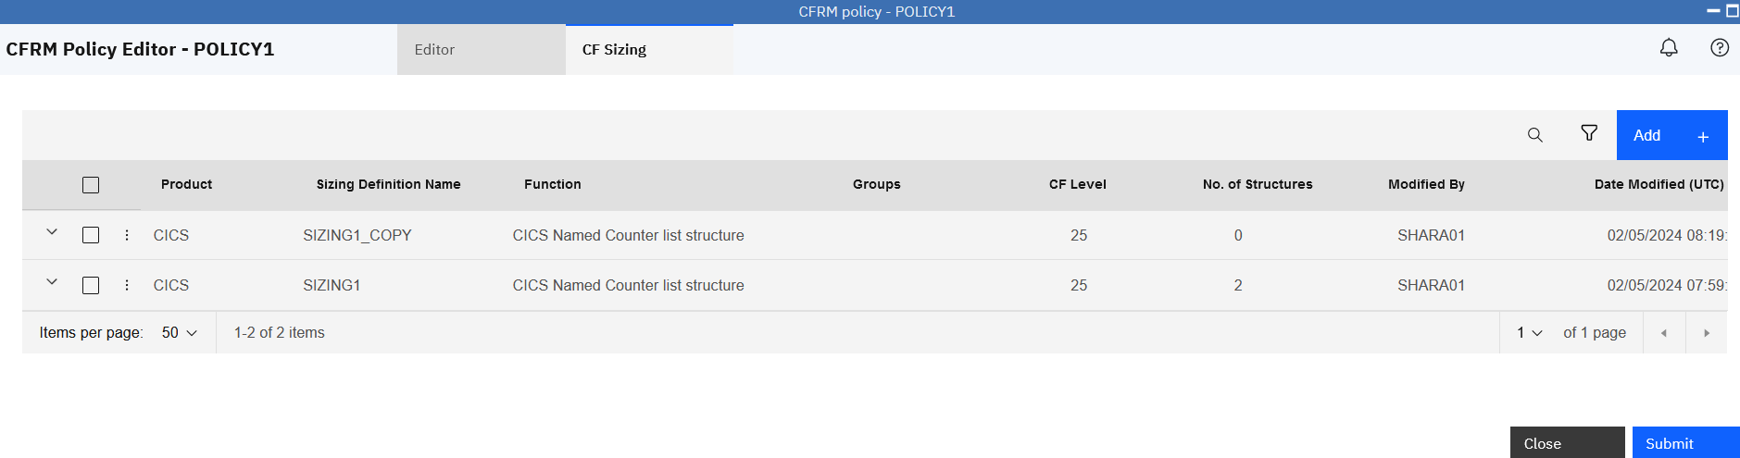

You can apply modifications and sizing to a set of CF sizing definitions at one time. This approach can save your time compared with editing sizing definitions one by one.

Select a set of CF sizing that you want to modify, click **Modify and Size**.

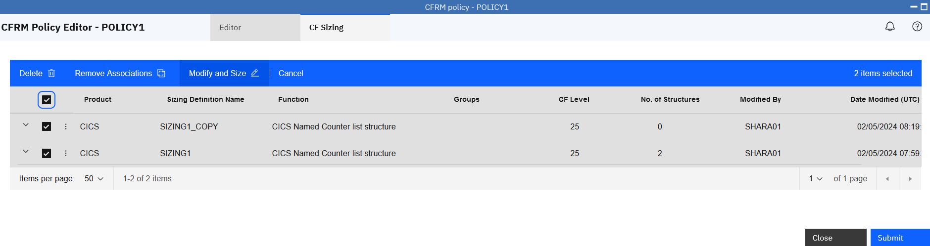

In the Modify and Size Multiple CF Sizing Definitions, enter values for the attributes that you want to modify. These values are applied to the selected CF sizing definitions, which are listed under **Modify and Size Structures in Selected CF Sizing Definitions.**

Set **50** as Results Modifier. Click **Next.**

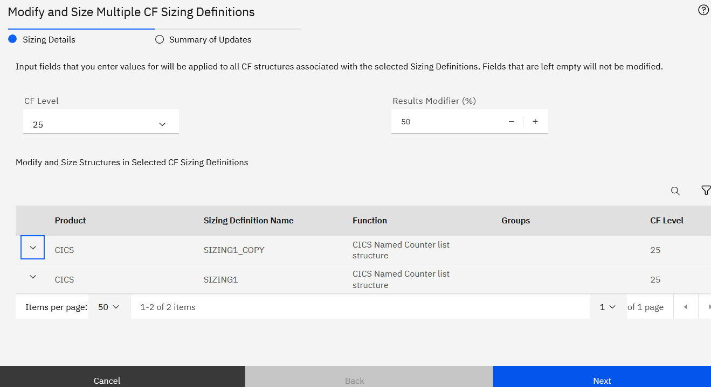

Click **Finish** to confirm your update.

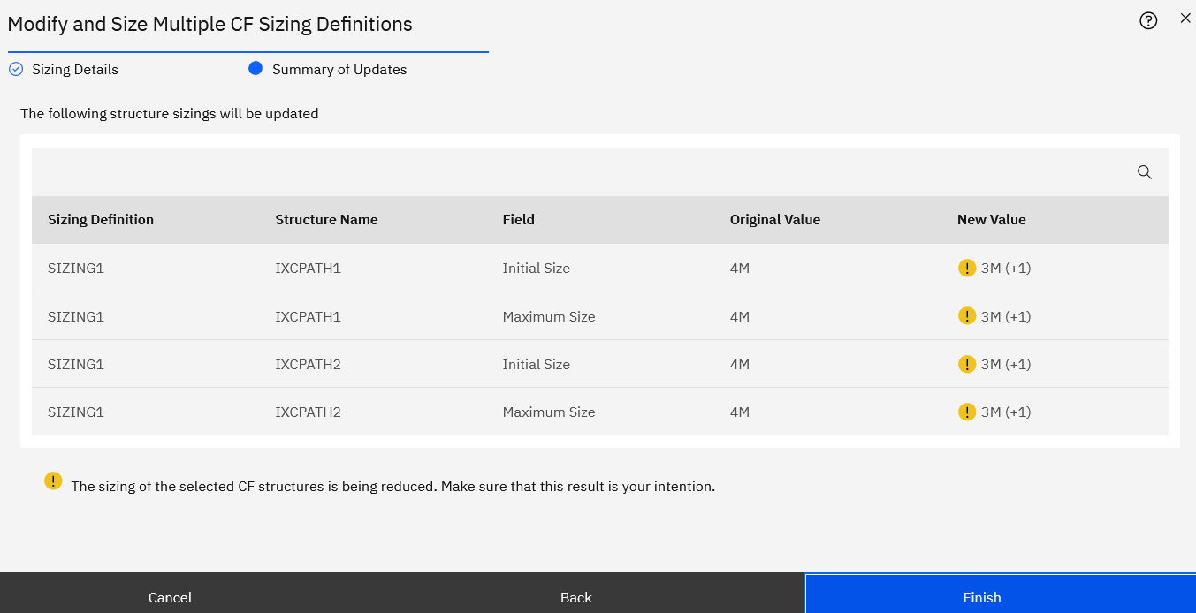

Click **Editor** tab, then click **CF Structures** tab, you can see **Maximum Size** and **Initial Size** value of the two structures associated with CF sizing definition SIZING1 are updated.

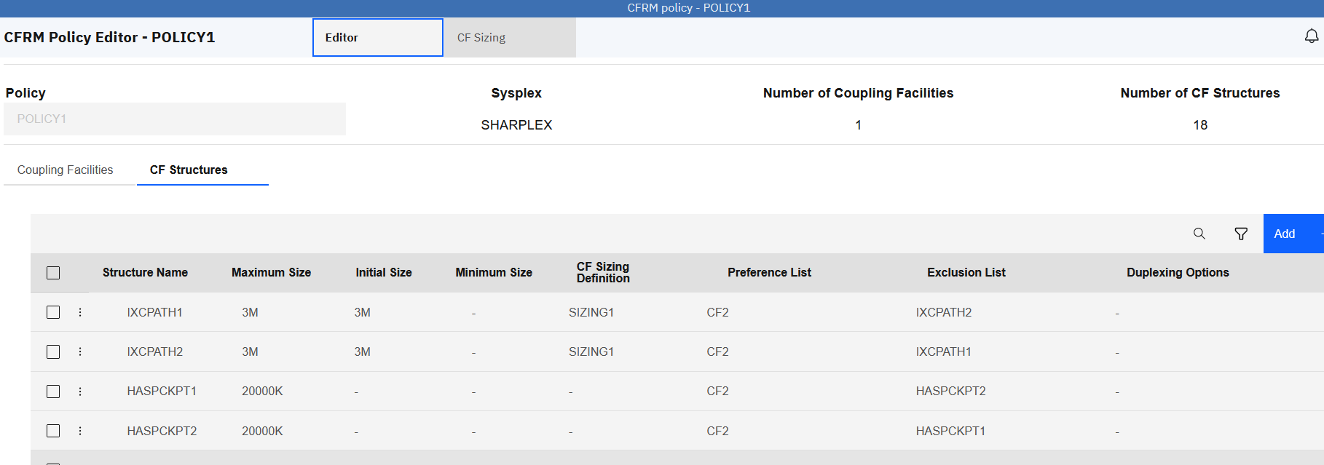

After you have done all update, **Submit** button can be used to save changes. Since you are operating with a shared system, we won’t perform Submit action.

In the CF Sizing tab of CFRM Policy Editor, click the action icon in front of a CF sizing definition, open action menu, move cursor to Remove Association, click **Remove Association**.

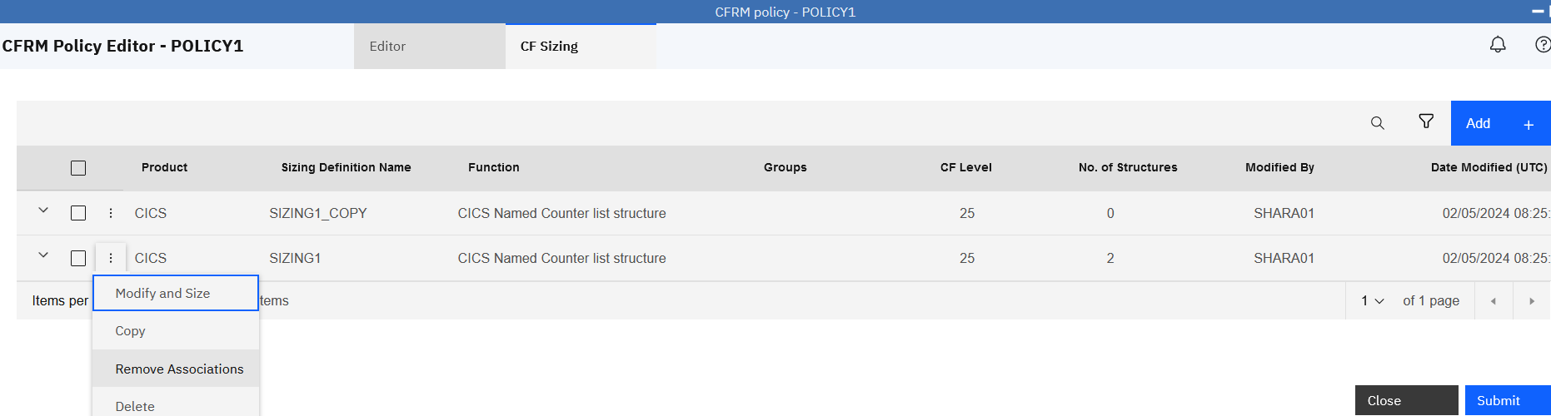

In the Remove Structure Associations, click **OK.**

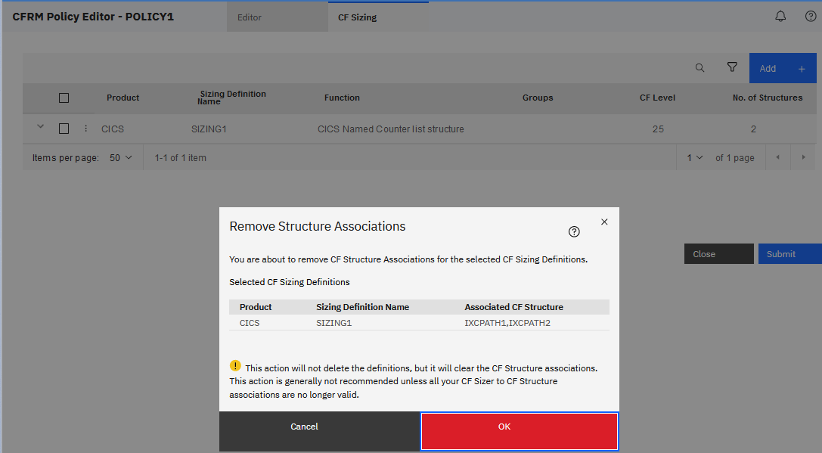

In the CFRM Policy Editor, **No. of structures** of CF sizing definition SIZING1 is updated.

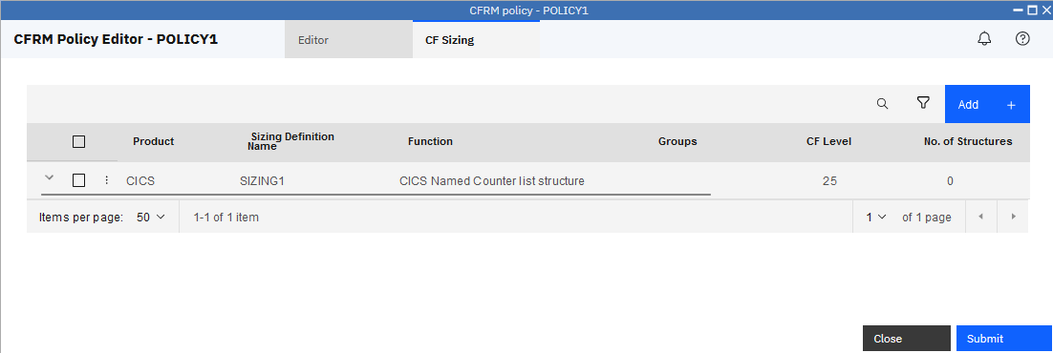

Click **Editor** tab, then click **CF Structures** tab, you can see the **CF Sizing Definition** attribute value of the two structures are updated to none.

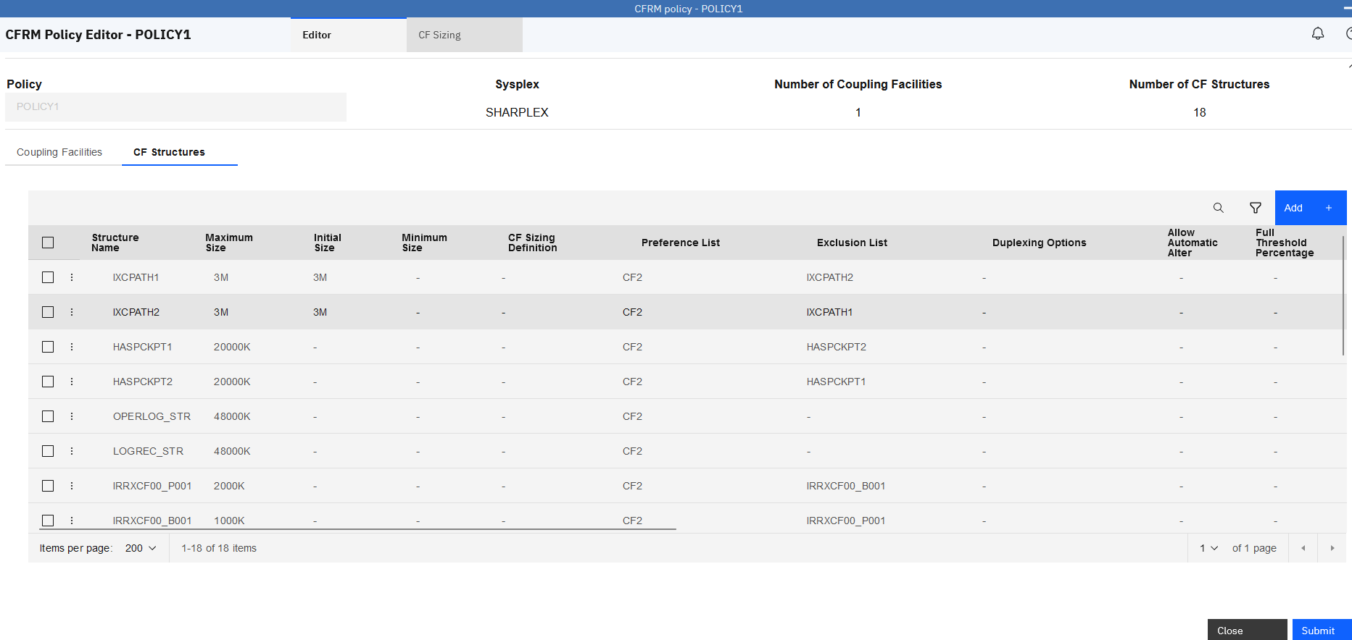

After you have done all update, **Submit** button can be used to save changes. Since you are operating with a shared system, we won’t perform Submit action.

Now Click **Close** to go back to CFRM Administrator Policies.

In the CFRM Administrator Policies, select the policy you created in the beginning, right click to show the action menu, move cursor to Delete, click **Delete.**

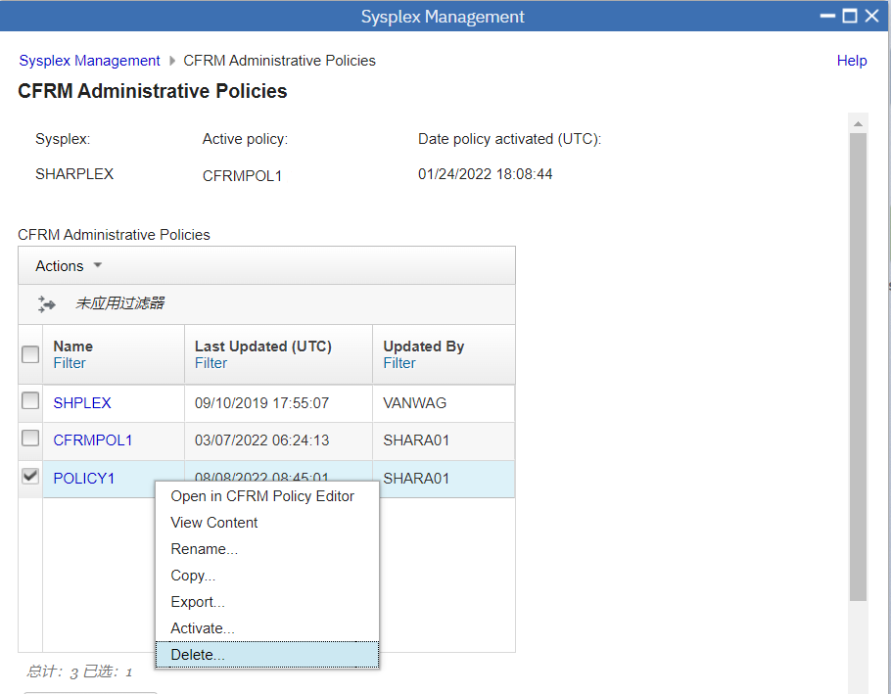

In Confirm Delete Policy, click **OK** to submit.

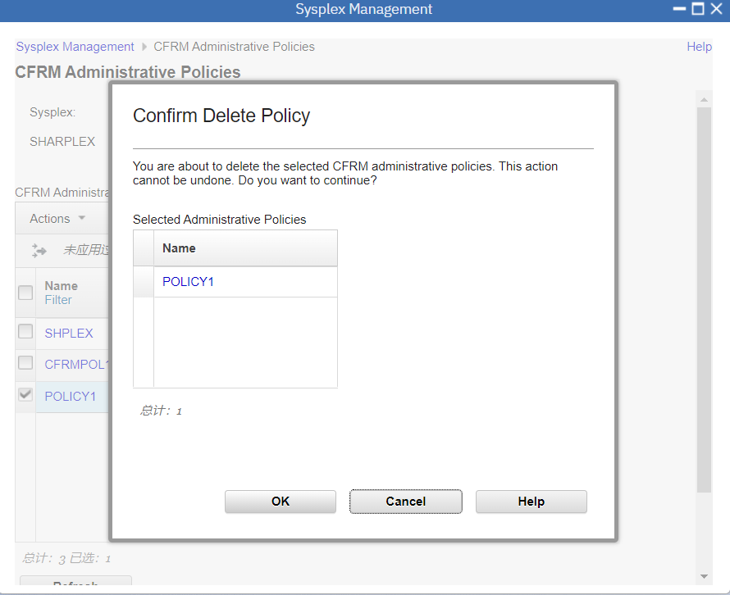

In CFRM Administrator Policies, you can see the policy “POLICY1” is deleted.

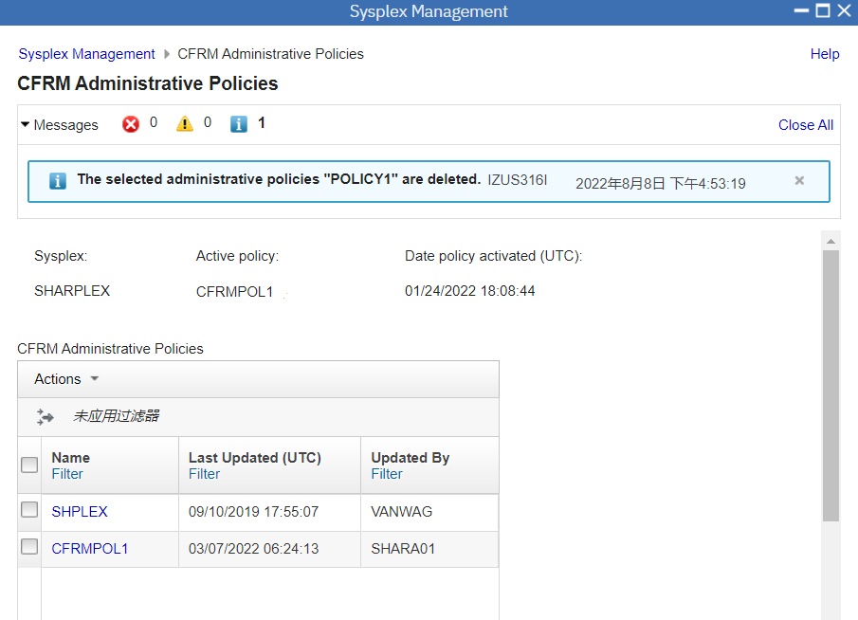

1. Export Policy

Now let’s switch back to z/OSMF Desktop. You can do that by minimize all z/OSMF windows or just double click on the z/OSMF Desktop background. On the right corner of the z/OSMF task bar, click on **Data Set and File Search** icon.

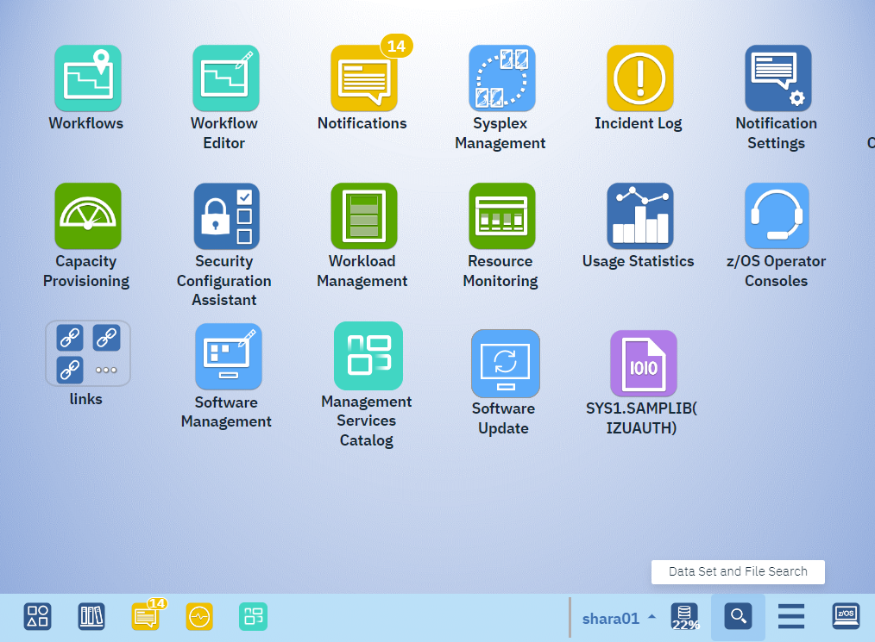

In Data Set and Search dialog, click **Create Data Set, Data Set Member and File** on the top right of the dialog.

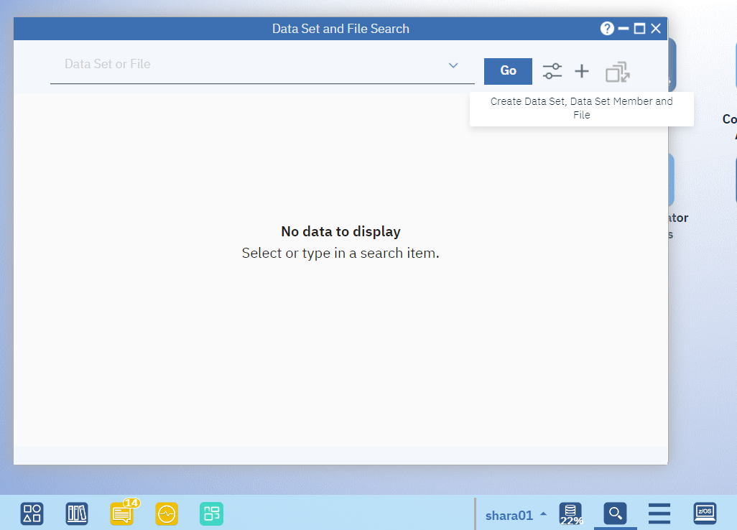

In New File or Directory dialog, check **File or Directory**, input file name you want to create in File or Directory Name field. **To ensure that the file name is unique, please use username as your file name**. Below screen shot is using user shara01, therefore, the input for “File or Directory Name” is /tmp/shara01.out. Click **OK** to create the file.

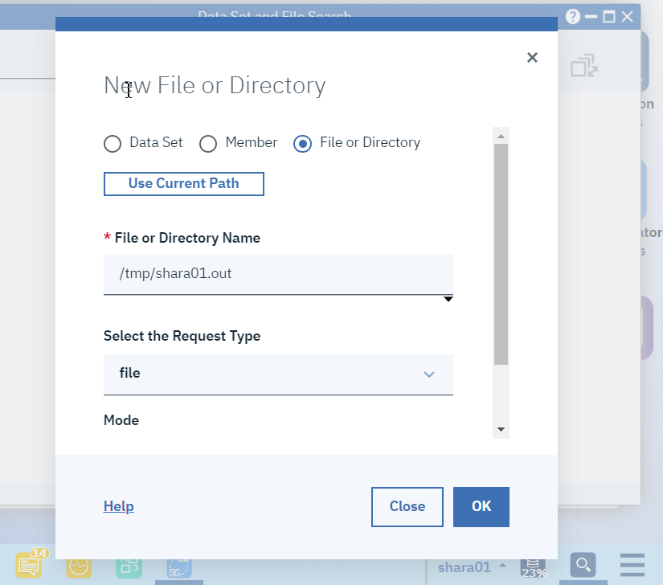

After the file is created successfully, click **Close** button to close the dialog.

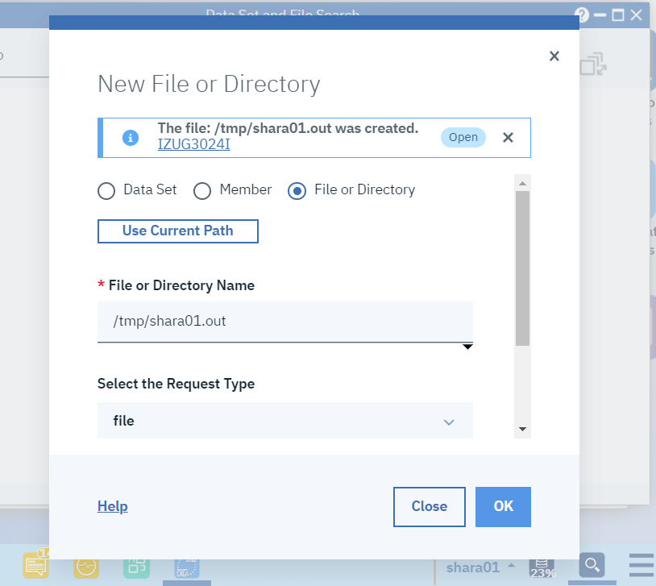

Then close the Data Set and File Search dialog by clicking X icon on the top right of the dialog.

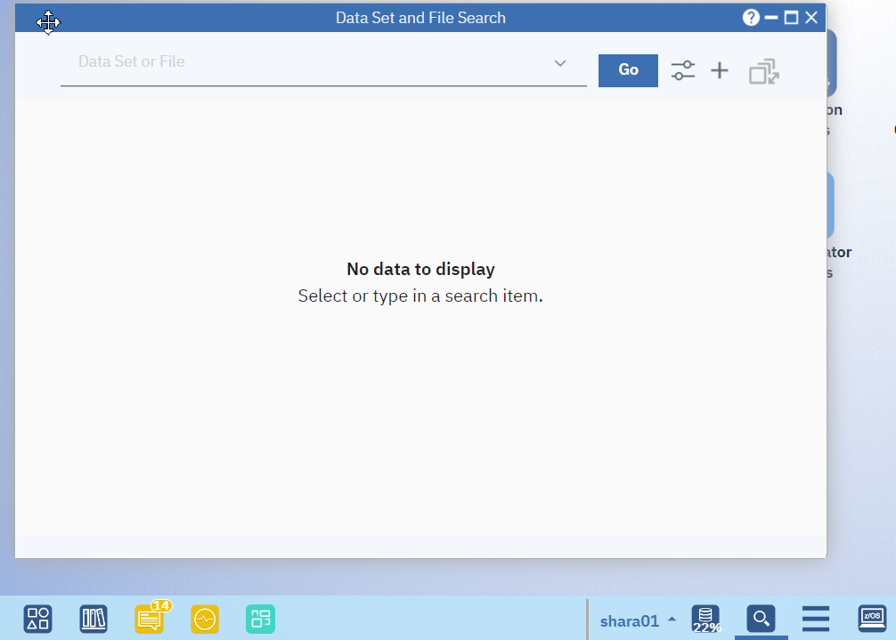

Now switch back to Sysplex Management window, open CFRM Administrative Policies panel, select the policy “SHPLEX”, right click to open action menu, then select **Export**.

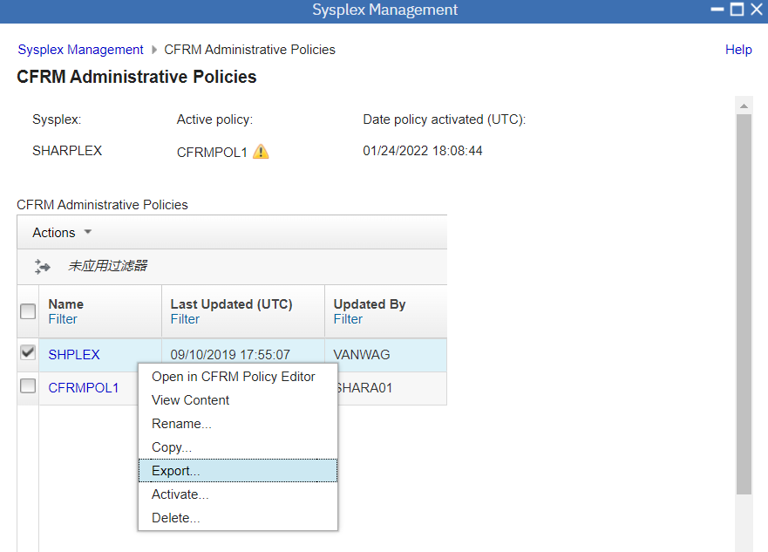

In Export CFRM Administrative Policy, input the filename you created in prior step (Note that your file should start with your lab user id). Click **OK** to export the policy.

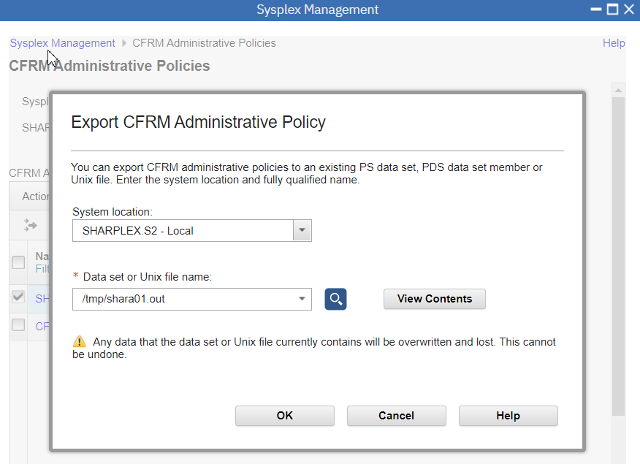

In Confirm Export CFRM Administrative Policy, click **OK** to confirm.

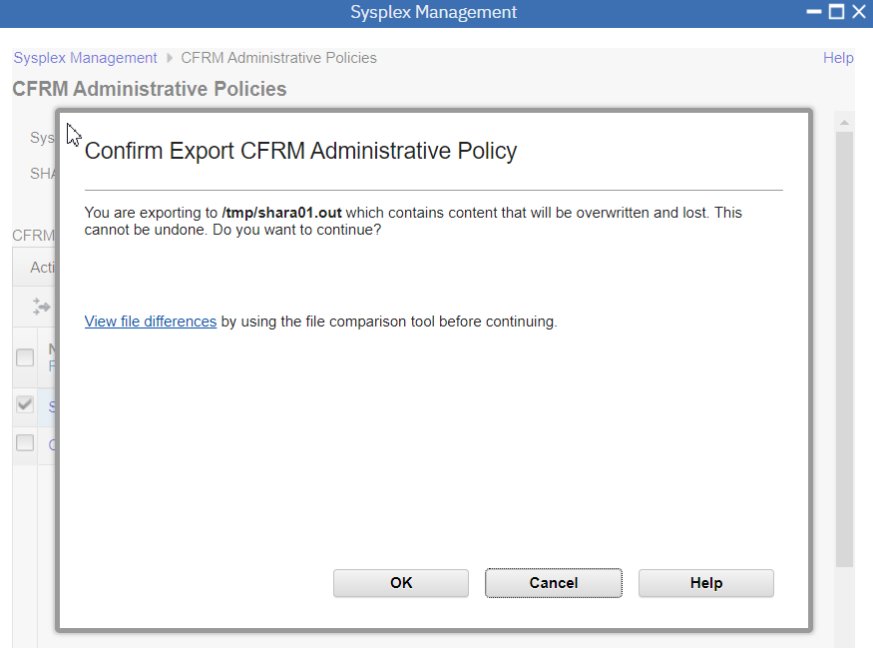

In the policy list, you can see the msg shows that policy is exported successfully.

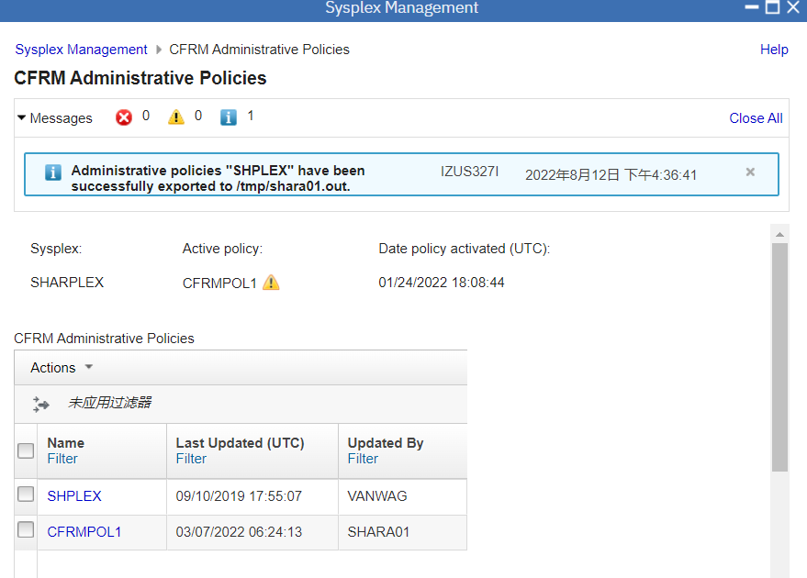

1. Import Policy

In CFRM Administrative Policies panel, click **Actions** drop down, select **Import**.

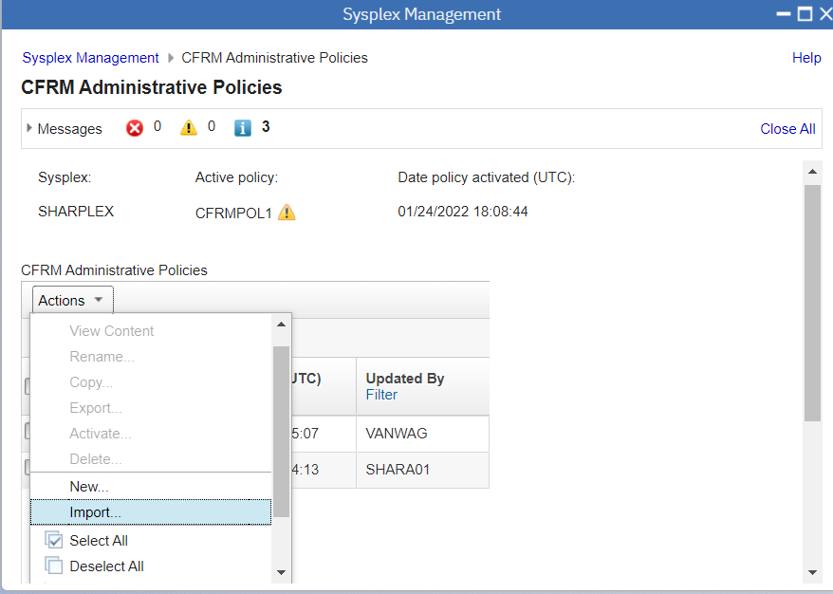

In Import CFRM Administrative Policy dialog, check **Policy in a dataset or Unix file**. In **Data set or Unix file name** field, input filename that you exported policy to in the prior step. Click **OK** to continue.

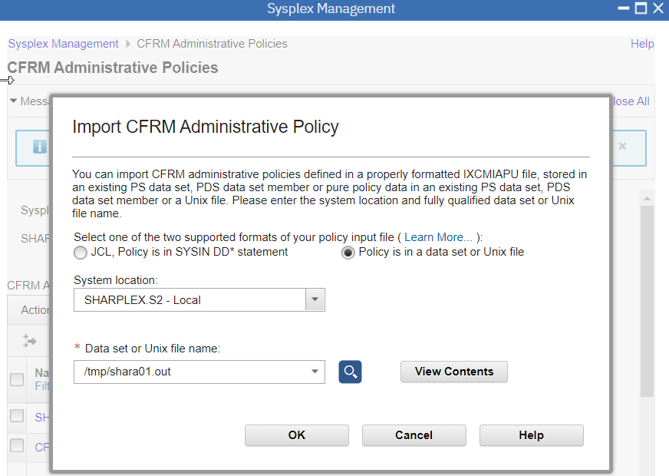

In Confirm Import CFRM Administrative Policy, click **Cancel** button as we don’t want every Lab user to really import a policy to the system. The earlier steps show that how you could import a policy to z/OSMF CFRM Policy Editor so that you can use CFRM Policy Editor to work with your policy later.

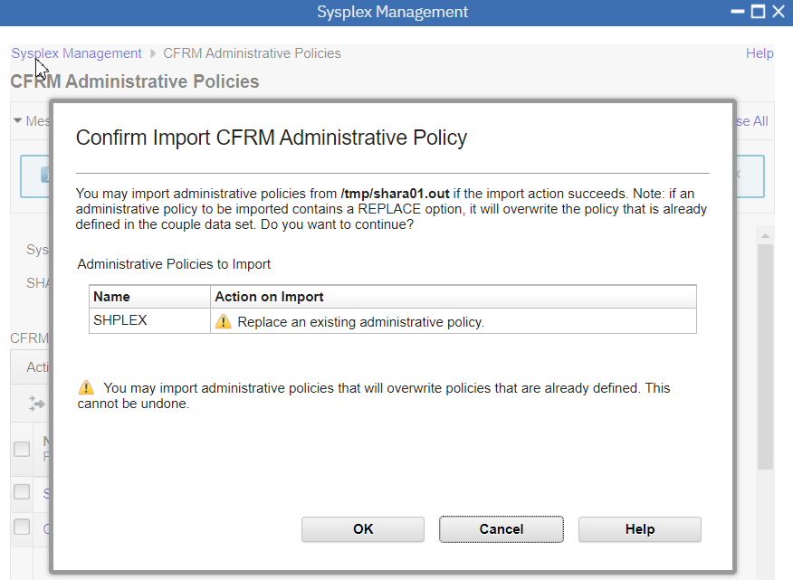

## Exercise review and wrap-up

In this lab, you became familiar with the z/OSMF Sysplex Management plugin by completing the following activities:

1. Log in to z/OSMF.

2. Open Sysplex Management.

3. Access Topology View of Sysplex.

4. Access Physical View of Sysplex.

5. View Properties of Couple Data Set

6. Open Coupling Facility Structures.

7. Access CF Connectivity View of Sysplex.

8. Access CF Connectivity Detail View of Sysplex.

9. Check Command log.

10. Switch Alternate to Primary.

11. Check Warning icon.

12. Check Notification.

13. List CFRM Policies

14. Work with CFRM Policy Editor

15. Work with CF Sizing

16. Export Policy

17. Import Policy

